COMPLETE TENSORFLOW 2 and KERAS DEEP LEARNING BOOTCAMP

Spis treści

Python setup 2

Command Line Basics 2

Shortcuts 2

Python Object and Data Structure Basics 2

# Python setup

## Command Line Basics

|  |  |
| --- | --- |
| Command |  |
| cd | Current directory |
| dir | Contents of directory |
| Cd *foldername* | Go to folder |
| Cd .. | Go back |
| Tab | Hints |
| cls | Clear cmd |

## Shortcuts

|  |  |
| --- | --- |
| Shortcut | Description |
| Shift + Tab | Show signature of method |
|  |  |
|  |  |

# Python Object and Data Structure Basics

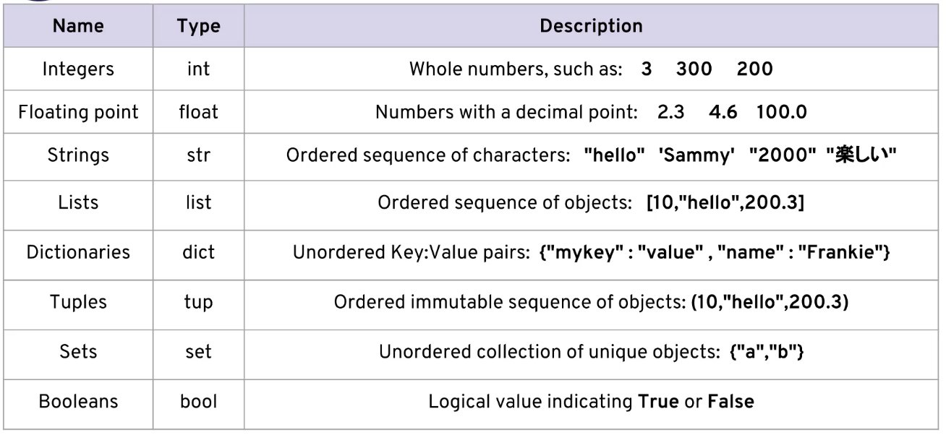

# Couse Overview, Installs, and Setup

## Course Setup and Installation

Create virtual environment in Anaconda Prompt:

conda create -n mytfenv python=3.7

To activate this environment, use

conda activate mytfenv

To deactivate an active environment, use

conda deactivate

# NumPy Crash Course

## Introduction to NumPy

* Open source numerical library used for working with mathematical functions with multi-dimensional array and matrix data structures.
* Already installed in our environment and is very common in Data Science and Machine Learning.
* Numpy arrays use less memory than normal python lists.
* A normal python list is a group of pointers to separate Python objects (e.g. the numbers inside the list)
* A numpy array is designed to be an array of uniform values, without using space for type pointers.
* Numpy can also read in information faster than normal python and has lots of convenient broadcasting operations that can be performed across array dimensions.

# Pandas Crash Course

## Introduction to Pandas

* Pandas stands for **Pan**el-**Da**ta.
* It is the most popular library for data handling for Python and is built directly off of NumPy.
* Since we will be continuously working with data in this course, we will use pandas to read in our data, clean the data, and even perform feature engineering with pandas.
* Pandas relies on some core data structures for its operations:
  + Series
    - Data array with a named index
  + DataFrame
    - A data “matrix” with labeled index and columns.

GroupBy 0 copy from notebook the table

Data input output – documentation

Colors - matplotlib

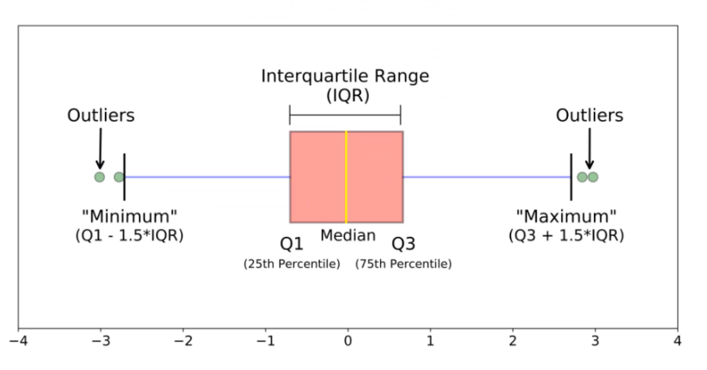

# Machine Learning Concepts Overview

## What is Machine Learning?

What is Machine Learning?

* Machine learning is a method of data analysis that automates analytical model building.
* Using algorithms that iteratively learn from data, machine learning allows computers to find hidden insights without being explicitly programmed where to look.

What is used for?

* Fraud detection.
* Web search results.
* Real-time ads on web pages
* Credit scoring.
* Prediction of equipment failures.
* New pricing models.
* Network intrusion detection.
* Recommendation Engines
* Customer Segmentation
* Text Sentiment Analysis
* Customer Churn
* Pattern and image recognition.
* Email spam filtering.

What is Neural Networks?

* Neural Networks are a way of modeling biological neuron systems mathematically.
* These networks can then be used to solve tasks that many other types of algorithms can not (e.g. image classification)
* Deep Learning simply refers to neural networks with more than one hidden layer.

Machine Learning

* Supervised
* Unsupervised

**Machine Learning** - Automated analytical models.

**Neural Networks** - A type of machine learning architecture modeled after biological neurons.

**Deep Learning** - A neural network with more than one hidden layer.

## Supervised Learning Overview

* **Supervised learning** algorithms are trained using **labeled** examples, such as an input where the desired output is known.
* For example, a segment of text could have a category label, such as:
  + **Spam** vs. **Legitimate** Email
  + **Positive** vs. **Negative** Movie Review
* The network receives a set of inputs along with the corresponding correct outputs, and the algorithm learns by comparing its actual output with correct outputs to find errors.
* It then modifies the model accordingly.
* Supervised learning is commonly used in applications where historical data predicts likely future events.

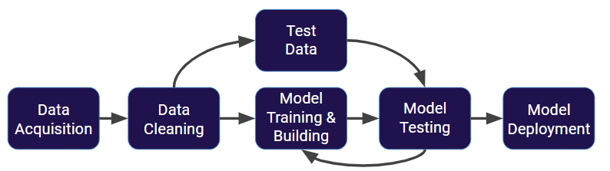

Steps

* Get your data! Customers, Sensors, etc…
* Clean and format your data (using Pandas)
* Split the data into Training and Test Sets

Sets

* What we just showed is a simplified approach to supervised learning, it contains an issue!
* Is it fair to use our single split of the data to evaluate our models performance?
* After all, we were given the chance to update the model parameters again and again.
* To fix this issue, data is often split into **3 sets**
  + Training Data
    - Used to train model parameters
  + Validation Data
    - Used to determine what model hyperparameters to adjust
  + Test Data
    - Used to get some final performance metric
* This means after we see the results on the **final test set** we don’t get to go back and adjust any model parameters!
* This final measure is what we label the true performance of the model to be.

## Overfitting

* Now that we understand the full process for supervised learning, let’s touch upon the important topics of **overfitting** and **underfitting.**
* **Overfitting**
  + The model fits too much to the noise from the data.
  + This often results in **low error on training sets but high error on test/validation sets.**
* Underfitting
  + Model does not capture the underlying trend of the data and does not fit the data well enough.
  + Low variance but high bias.
  + Underfitting is often a result of an excessively simple model.

|  |  |
| --- | --- |
| Data | Good Model |
|  |  |
| Overfitting | Underfitting |
|  |  |

* This data was easy to visualize, but how can we see underfitting and overfitting when dealing with multi dimensional data sets?
* First let’s imagine we trained a model and then measured its error over training time.

|  |  |  |
| --- | --- | --- |
| Good model | | Bad model |
|  |  |  |

* When thinking about **overfitting** and **underfitting** we want to keep in mind the relationship of model performance on the training set versus the test/validation set.
* Let’s imagine we split our data into a **training set** and a **test set**
* We first see performance on the **training set**
* Next we check performance on the **test set**
* Ideally the model would perform well on both, with similar behavior.

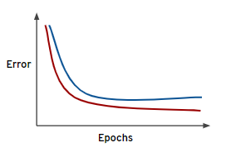

* But what happens if we overfit on the training data? That means we would perform poorly on new test data!

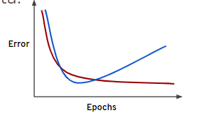

* This is a good indication of training too much on the training data, you should look for the point to cut off training time!

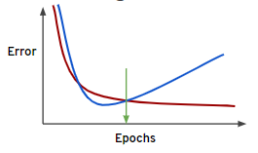

## Evaluating Performance – Regression Error Metrics

### Classification

* The key classification metrics we need to understand are:
  + Accuracy
  + Recall
  + Precision
  + F1-Score
* Example – real world
  + But first, we should understand the reasoning behind these metrics and how they will actually work in the real world!
  + Typically in any classification task your model can only achieve two results:
    - Either your model was **correct** in its prediction.
    - Or your model was **incorrect** in its prediction.
  + Fortunately incorrect vs correct expands to situations where you have multiple classes.
  + For the purposes of explaining the metrics, let’s imagine a **binary classification** situation, where we only have two available classes.
  + In our example, we will attempt to predict if an image is a dog or a cat.
  + Since this is supervised learning, we will first **fit/train** a model on **training data**, then **test** the model on **testing data**.
  + Once we have the model’s predictions from the **X_test** data, we compare it to the **true y values** (the correct labels).

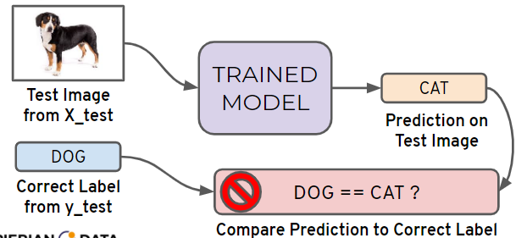

* + We repeat this process for all the images in our X test data.
  + At the end we will have a count of correct matches and a count of incorrect matches.
  + The key realization we need to make, is that **in the real world**, **not all incorrect or correct matches hold equal value!**
  + Also in the real world, a single metric won’t tell the complete story!
  + To understand all of this, let’s bring back the 4 metrics we mentioned and see how they are calculated.
  + We could organize our predicted values compared to the real values in a **confusion matrix.**
* Accuracy
  + Accuracy in classification problems is the **number of correct predictions** made by the model divided by the **total number of predictions.**
 $$acurancy=\frac{number of correct predictions}{total number of predictions}$$

 + Accuracy is useful when target classes are well balanced
  + In our example, we would have roughly the same amount of cat images as we have dog images.
  + Accuracy is **not** a good choice with **unbalanced** classes!
  + Imagine we had 99 images of dogs and 1 image of a cat.
  + If our model was simply a line that always predicted **dog** we would get 99% accuracy!
  + Imagine we had 99 images of dogs and 1 image of a cat.
  + If our model was simply a line that always predicted **dog** we would get 99% accuracy!
  + In this situation we’ll want to understand **recall** and **precision**
* Recall
  + Ability of a model to find all the relevant cases within a dataset.
  + The precise definition of recall is the number of true positives **divided by** the number of true positives plus the number of false negatives.
$$recall=\frac{number of true positives}{number of true positives+number of false negatives}$$

* Precision
  + Ability of a classification model to identify only the relevant data points.
  + Precision is defined as the number of true positives divided by the number of true positives plus the number of false positives.
$$precision=\frac{number of true positives}{number of true positives+number of false positives}$$

* Recall and Precision
  + Often you have a trade-off between Recall and Precision.
  + While recall expresses the ability to find all relevant instances in a dataset, precision expresses the proportion of the data points our model says was relevant actually were relevant.
* F1-Score
  + In cases where we want to find an optimal blend of precision and recall we can combine the two metrics using what is called the F1 score.
  + The F1 score is the harmonic mean of precision and recall taking both metrics into account in the following equation:
 $$F_{1}=2*\frac{recall*precision}{recal+precision}$$

 + We use the harmonic mean instead of a simple average because it punishes extreme values.
  + A classifier with a precision of 1.0 and a recall of 0.0 has a simple average of 0.5 but an F1 score of 0.
* Confusion matrix
  + We can also view all correctly classified versus incorrectly classified images in the form of a confusion matrix.

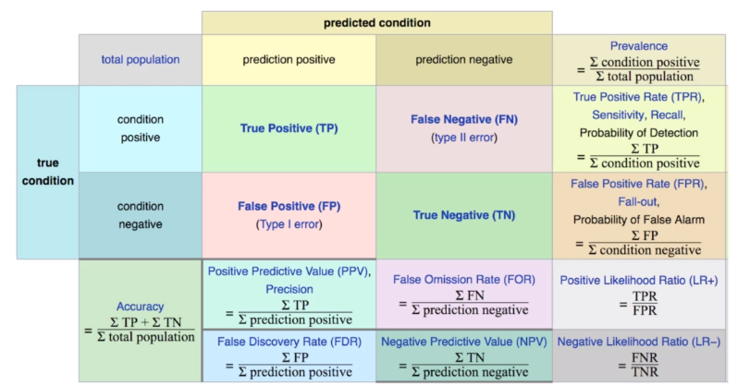

### Regression

* Regression is a task when a model attempts to predict continuous values (unlike categorical values, which is classification)
* We need metrics designed for **continuous** values!
* For example, attempting to predict the price of a house given its features is a **regression task.**
* Attempting to predict the country a house is in given its features would be a classification task.
* Let’s discuss some of the most common evaluation metrics for regression:
  + **Mean Absolute Error (MEA)**
    - This is the mean of the absolute value of errors
    - Easy to understand
 $$\frac{1}{n}\sum_{i=1^{\left|y_{i}-{\hat{y}}_{i}\right|}}^{n}{ }$$

   - MEA won’t punish large errors however

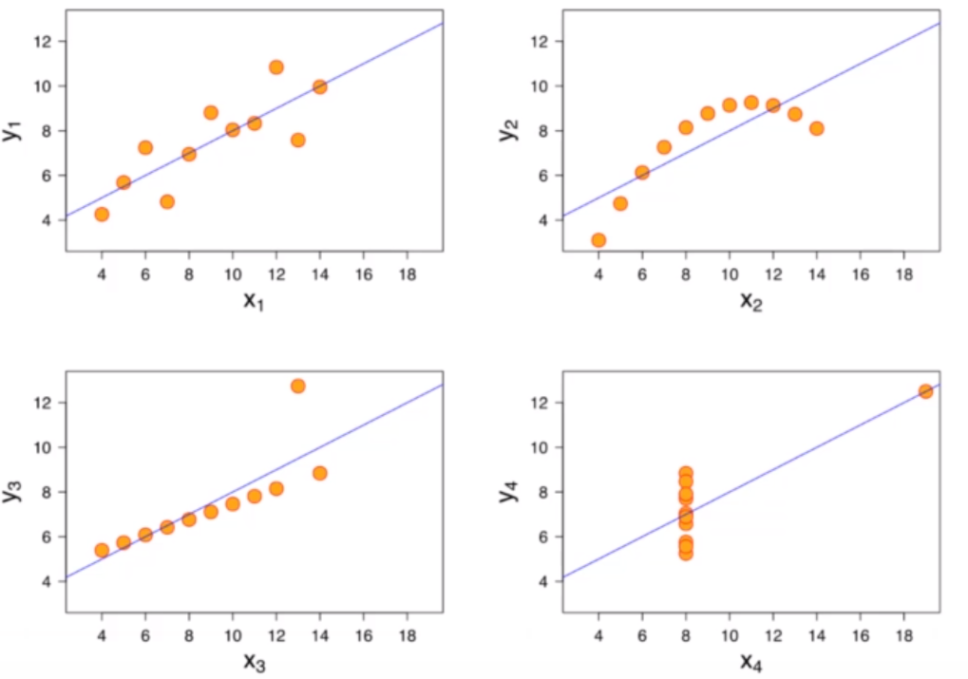

* + **Mean Squared Error (MSA)**
    - This is the mean of the squared errors
    - Large errors are noted more than with MAE, making MSE more popular
 $$\frac{1}{n}\sum_{i=1^{{\left(y_{i}-{\hat{y}}_{i}\right)}^{2}}}^{n}{ }$$

 + **Root Mean Square Error**
    - This is the root of the mean of the squared errors
    - Has the same unit as y
 $$\sqrt{\frac{1}{n}\sum_{i=1^{{\left(y_{i}-{\hat{y}}_{i}\right)}^{2}}}^{n}{ } }$$

 + Is this value of RMSE good? – Depends on context!
  + Compare error metric to the average value of the label into data set to try to get an intuition of its overall performance

## Unsupervised Learning

* We’ve covered supervised learning, where the **label was known** due to **historical labeled data.**
* But what happens when we don’t have historical labels?
* There are certain tasks that fall under unsupervised learning:
  + Clustering
  + Anomaly Detection
  + Dimensionality Reduction
* Clustering
  + Grouping together **unlabeled** data points into categories/clusters
  + Data points are assigned to a cluster based on similarity
* Anomaly Detection
  + Attempts to detect outliers in a dataset
  + For example, fraudulent transactions on a credit card.
* Dimensionality Reduction
  + Data understand underlying trends within a data set.
* Unsupervised Learning
  + It’s important to note, these are situations where we **don’t** have the correct answer for historical data!
  + Which means evaluation is much harder and more nuanced!

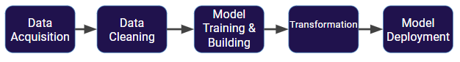

# Basic Artificial Neural Networks - ANNs

## Introduction to ANN Section

* Theory Topics
  + Perceptron Model to Neural Networks
  + Activation Functions
  + Cost Functions
  + Feed Forward Networks
  + BackPropagation
* Coding Topics
  + TensorFlow 2.0 Keras Syntax
  + ANN with Keras
    - Regression
    - Classification
  + Exercises for Keras ANN
  + Tensorboard Visualizations

## Perceptron Model

* To begin understanding deep learning, we will built up our model abstractions:
  + Single Biological Neuron
  + Perceptron
  + Multi-layer Perceptron Model
  + Deep Learning Neural Network
* As we learn about more complex models, we’ll also introduce concepts, such as:
  + Activation Functions
  + Gradient Descent
  + BackPropagation
* If the whole idea behind deep learning is to have computers artificially mimic biological natural intelligence, we should probably build a general understanding of how biological neurons work
* Stained Neurons in cerebral cortex

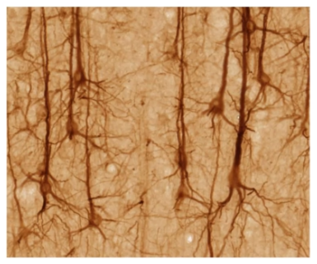

* Illustration of biological neurons

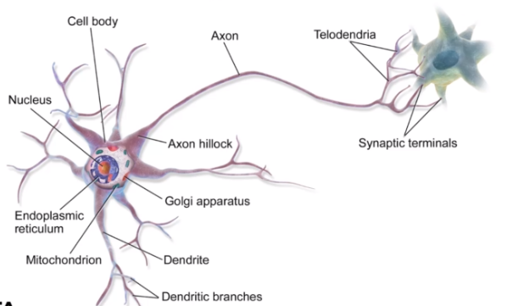

* Simplify Biological Neuron model
  + Dendrites – input
  + Nucleus – calculations
  + Axon - output

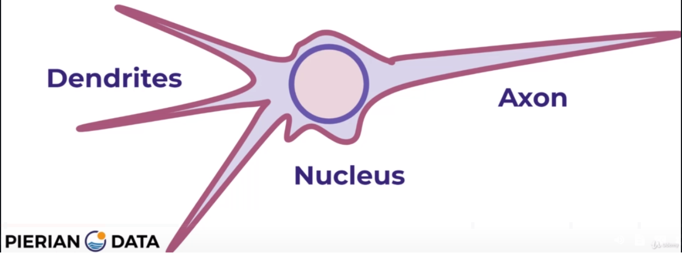

* A perceptron was a form of neural network introduced in 1958 by Frank Rosenblatt
* Amazingly, even back then he saw huge potential
  + ‘…perceptron may eventually be able to learn, make decision, and translate languages’
* However, in 1969 Marvin Minsky and Seymour Papert’s published their book **Perceptrons**
* It suggested that there were severe limitations to what perceptrons could do
* This marked the beginning of what is known as the AI Winter, with little funding into AI and Neural Networks in the 1970s
* Fortunately for us, we now know the amazing power of neural networks, which all stem from the simple perceptron model, so let’s head back and convert out simple biological neuron model into the perceptron model
* Example:
  + If f(x) is just a sum, then y=x1+x2
  + Realistically, we would to be able to adjust some parameter in order to ‘learn’
  + Let’s add an adjustable weight we multiply against x
  + Now y=x1w1+x2w2
  + We could update the **weights** to effect **y**
  + But what if an x is zero? W won’t change anything!
  + Let’s add in a **bias** term **b** to the inputs
  + y=(x1w1 + b) + (x2w2 + b)
  + We can expand this to a generalization

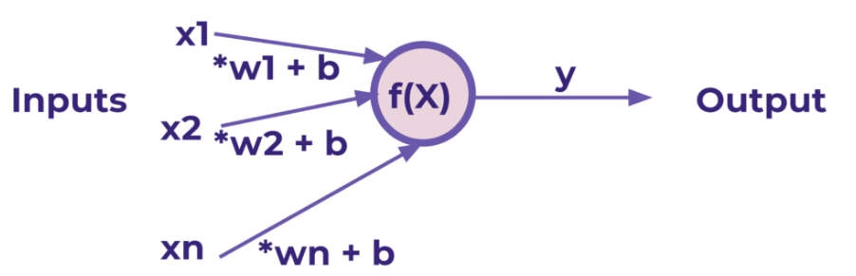

* We’ve been able to model a biological neuron as a simple perceptron! Mathematically our generalization was:

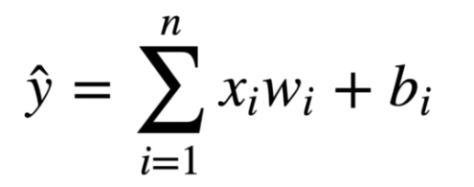

* Later on we will se how we can expand this model to nave X be a **tensor** of information (an n-dimensional matrix)

## Neural Networks

* A single perceptron won’t be enough to learn complicated systems
* Fortunately, we can expand on the idea of a single perceptron, to create a multi-layer perceptron model
* To build a network of perceptrons, we can connect layers of perceptrons, we can connect layers of perceptrons, using a **multi-layer perceptron model**

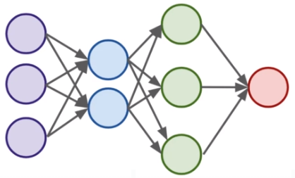

* ↑ - **fully connected layer** – every neuron is connected to every neuron in the next layer
* The outputs of one perceptron are directly fed into as inputs to another layer
* **Neuron = perceptron**
* This allows the network as a whole to learn about interactions and relationship between features
* The first layer is a **input layer** – it receives a data

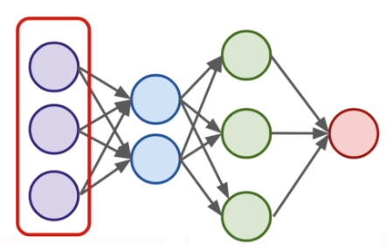

* Layers between the input and output layers are the **hidden layers** – hidden layers are difficult to interpret, due to their high interconnectivity and distance away from known input or output values

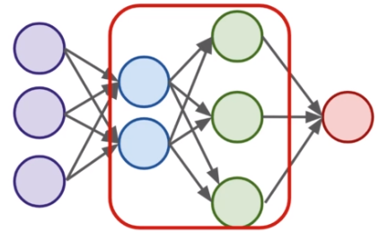

* The last layer is the **output layer** – Note: this last layer can be more than one neuron

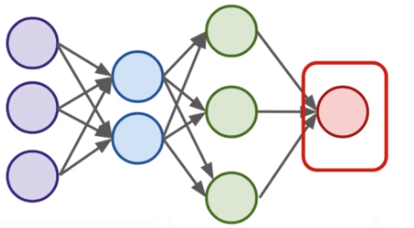

* Neural Networks become **“deep neural networks”** if then contain 2 or more hidden layers

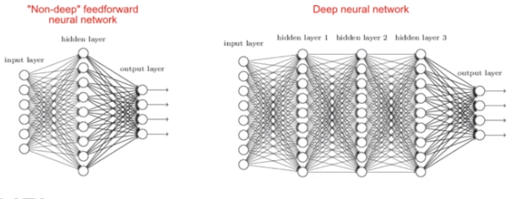

* Terminology
  + Input Layer – First Layer that directly accepts real data values
  + Hidden Layers - Any layer between input and output layers
  + Output Layer – The final estimate of the output
* What is incredible about the neural network framework is that it can be used to approximate any function
* Zhou Lu and later in Boris Hanin proved mathematically that Neural Networks can approximate any convex continuous function (“Universal Approximation Theorem”)
* Previously in our simple model we saw that the perceptron itself contained a very simple summation function f(x)
* For most use cases however that won’t be useful, we’ll want to be able to set constraints to our output values, especially in classification tasks
* In a classification tasks, it would be useful to have all outputs fall between 0 and 1
* These values can then present probability assignments for each class
* In the next lecture, we’ll explore how to use **activation functions** to set boundaries to output values from the neuron

## Activation Functions

* Recall that inputs **x** have a weight **w** and a bias term **b** attached to them in the perceptron model
* Which means we have: **x*w + b**
  + Clearly **w** implies how much weight or strength to give the incoming input
  + We can thing of **b** as an offset value, making **x*w** have to reach a certain threshold before having an effect
  + For example if **b=-10**
    - Then the effects of **x*w** won’t really start to overcome the bias until their product surpasses 10
    - After that, then the effect is solely based on the value **w**
    - Thus the term ‘bias’
  + Next we want to set boundaries for the overall output value of **x*w+b**
    - We can state **z=x*w+b**
    - And then pass **z** through some activation function to limit its value
* A lot of research has been done into activation functions and heir effectiveness
* Let’s explore some common activations functions
* Recall our simple perceptron has an f(x)
  + If we had a binary classification problem we would want an output of either 0 or 1

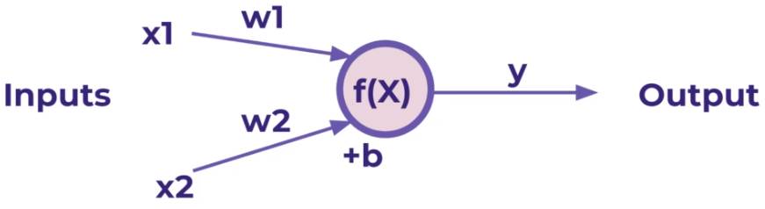

* Note:
  + To avoid confusion, let’s define the total inputs as a variable **z**, where **z=x*w+b**
  + In this context, we’ll then refer to activation functions as **f(z)**
  + Keep in mind, you will often see these variables capitalized **f(Z)** or **X** to denote a tensor input consisting of multiple values
* Activation functions
  + The most simple networks rely on basic **step function** that outputs 0 or 1
    - Regardless of the values, this always outputs 0 or 1
    - This sort of function could be useful for classification (0 or 1 class)
    - However, this is very ‘strong’ function, since small changes aren’t reflected
    - There is just an immediate cut off that splits between 0 and 1

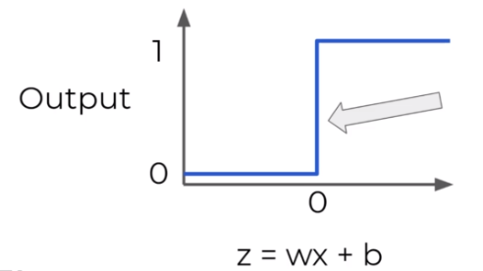

* + **Sigmoid function/Logistic function**
    - It would be nice if we could have a more dynamic function, for example the red line
    - Lucky for us, this is the sigmoid function! Also known as a logistic function
    - Changing the activation function used can be beneficial depending on the task
    - This still works for classification, and will be more sensitive to small changes

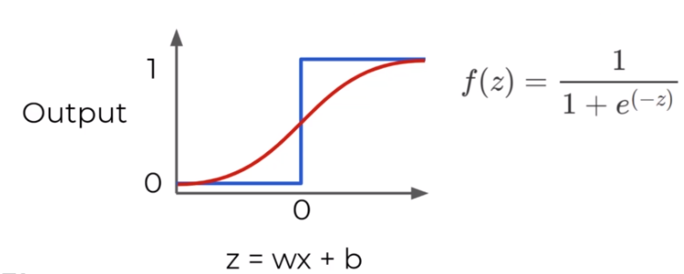

* + **Hyperbolic Tangent: tanh(z)**
    - Output between -1 and 1 instead of 0 to 1

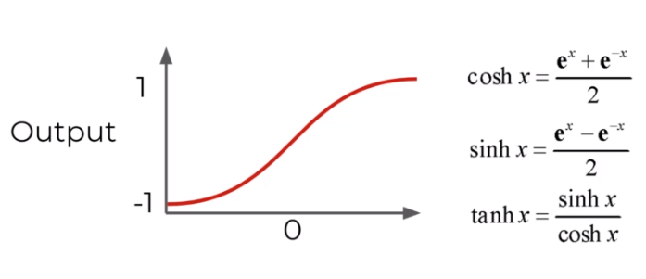

* + **Rectified Linear Unit (ReLU)**
    - This is actually a relatively simple function: max(0, z)
    - ReTU has been found to have very good performance, especially when dealing with the issue of **vanish gradient**
    - We’ll often default ReLU to its overall good performance

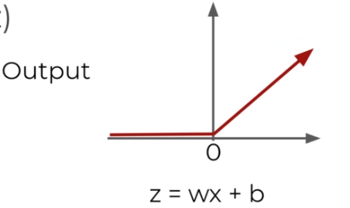

* + More: <https://en.wikipedia.org/wiki/Activation_function>

## Multi-Class Classification Considerations

* Notice all activation functions make sense for a single output, either a continuous label or trying to predict a binary classification (either a 0 or 1)
* But what should we do if we have a multi-class situation?
* There are 2 main types of multi-class situations
  + **Non-Exclusive Classes**
    - A data point can have multiple classes/categories assigned to it
    - Photos can have multiple tags (e.g. beach, family, vacation… etc.)
  + **Mutually Exclusive Classes**
    - Only one class/category assigned to it
    - Photos can be categorized as being in grayscale or full color photos. A phptp can not be both at the same time
* Organizing Multiple Classes
  + The easiest way to organize multiple classes is to simply have 1 output node per class
  + The single node could output a continuous regression value or binary classification (0 or 1) 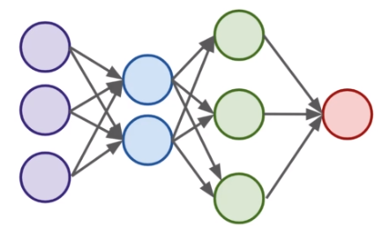
  + Let’s expand this output layer to work for the case of multi-classification
    - This means we will need to organize categories for this output layer
    - We can’t just have categories like ’red’, ‘blue’, ‘green’, etc…
    - Instead we use **one-hot encoding -** mutually exclusive classes

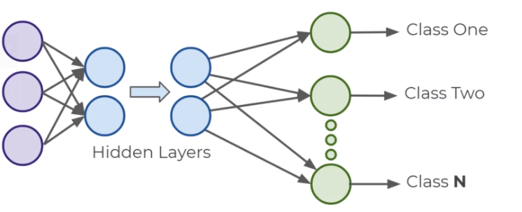

* **Mutually exclusive classes – One-hot encoding – Create dummy variables**

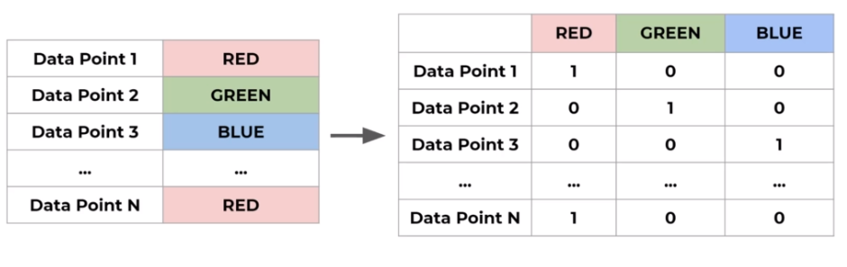

* Non-Exclusive Classes

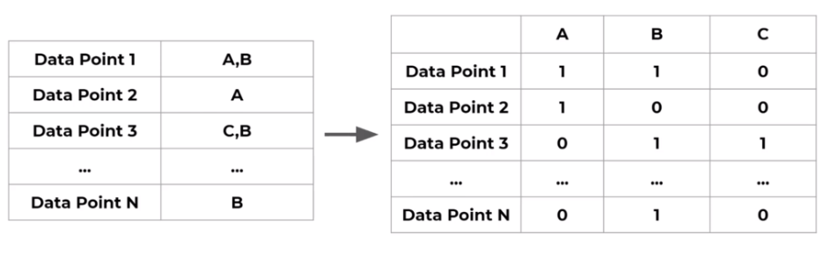

* Now that we have our data correctly organized, we just need to choose the correct classification activation function that the last output layer should have
  + Non-exclusive
    - Sigmoid function
      * Each neuron will output a value between 0 and 1, indicating the probability of having that class assigned to it
      * Sigmoid function for Non-Exclusive Classes

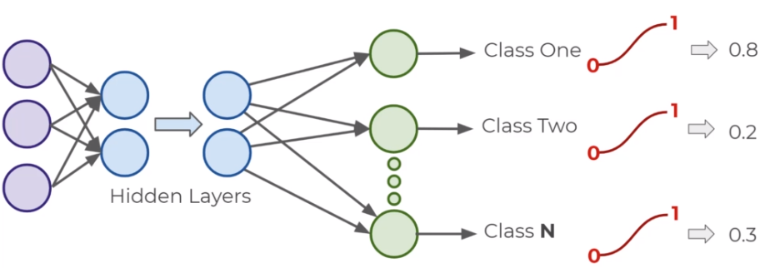

* + - * Keep in mind this allows each neuron to output independent of other classes, allowing for a single data point fed into the function to have multiple classes assigned to it
  + Mutually Exclusive Classes
    - But what we do when each data point can only have a single class assigned to it?
    - We can use the **softmax function** for this
    - Softmax Activation Function

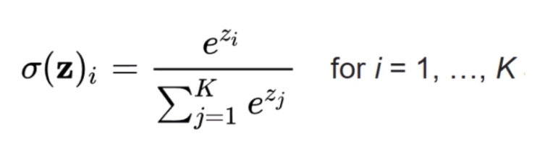

* + - * Softmax function calculates the probabilities distribution of the event over **K** different events
      * This function will calculate the probabilities of each target class over all possible target classes
      * The range will be 0 to 1, and **the sum of all the probabilities will be equal to one**
      * The model returns the probabilities of each class and the target class chosen will have the highest probability
      * He main thing to keep in mind is that if you use softmax for multi-class problems you get this sort of outputs

[Red, Green , Blue]

[0.1, 0.6, 0.3 ]

* + - * The probability for each class all sum up to 1. We choose the highest probability as our assignment

## Cost Functions and Gradient Descent

* We now understand that neural networks take in inputs, multiply them by weights, and add biases to them
* Then this result is passed through an activation function which at the end of all the layers leads to some output
* This output **ŷ** is the model’s estimation of what it predicts the label to be
* So after the network creates its prediction, how do we evaluate it?
* And after the evaluation how can we update the networks weights and biases?
* We need to take the estimated outputs of the network and then compare them to the real values of the label
* Keep in mind this is using the training data set during the fitting/training of the model
* The cost function (often referred to as a loss function) must be an average so it can output a single value
* We can keep track of our loss/cost during training to monitor network performance
* Variables:
  + We’ll use the following variables:
    - y to represent the true value
    - a to represent neuron’s prediction
  + In terms of weights and bias:
    - w*x+b=z
    - Pass z into activation function σ(Z)=a
  + One very common cost function is the quadratic cost function
  + We simply calculate the difference between the real values y(x) against our predicted values a(x)
  + Note: The notation shown here corresponds to vector inputs and outputs, since we will be dealing with a **batch** of training points and predictions
  + Notice how squaring this does 2 useful things for us, keeps everything positive and **punishes** large errors

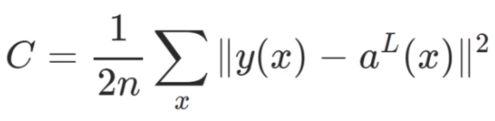

* + We can thing of the cost function as:

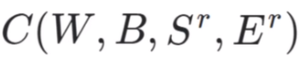

* + **W** is our neural network's weights, **B** is our neural network's biases, **Sr** is the input of a single training sample, and **Er** is the desired output of that training sample.
  + Notice how that information was all encoded in our simplified notation
  + The **a(x)** holds information about weights and biases
  + This means that if we have a huge network, we can expect **C** to be quite complex, with huge vectors of weights and biases
  + Here is a small network with all its parameters labeled

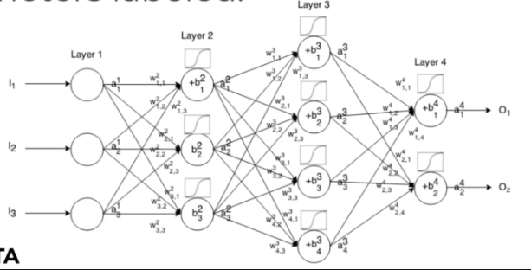

* That is a lot to calculate! How do we solve this?
  + In real case, this means we have some cost function **C** dependent lots of weights
    - **C(w1, w2, w3, …, wn)**
  + How do we figure out which weights lead us to the lowest cost?
  + For simplicity, let’s imagine we only had one weight in our cost function **w**
  + We want to **minimize** our loss/cost (overall error)
  + Which means we need to figure out what value of **w** result in the minimum of **C(w)**
  + Our ‘simple’ function **C(w)** – what value of **w** minimizes our cost?
  + Students of calculus know we could take a derivative and solve for 0

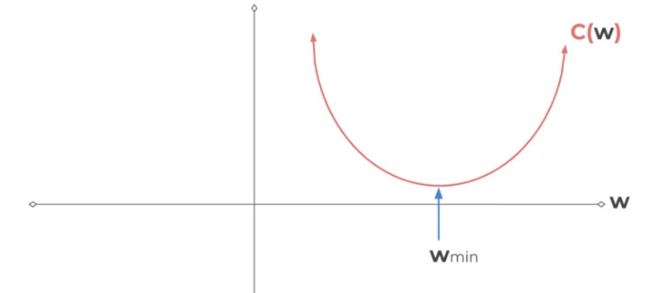

* + But recall our cost function will be very complex and it will be **n-dimensional**
    - And it will be **n-dimensional** since our networks will have 1000s weights
    - We can use **gradient descent** to solve this problem

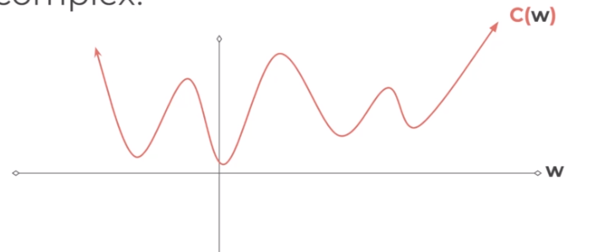

* + Let’s go back to our simplified version to see how this works
    - We can calculate the slope at the point
    - And we move in the downward direction of the slope

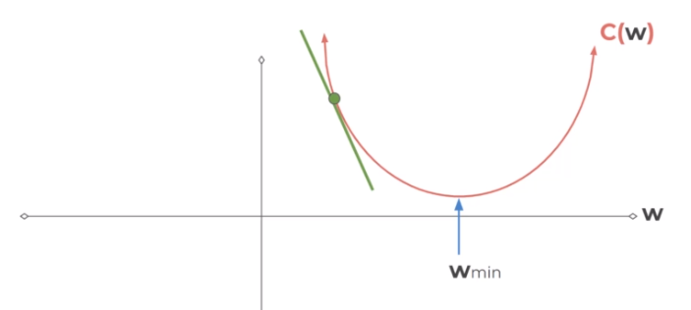

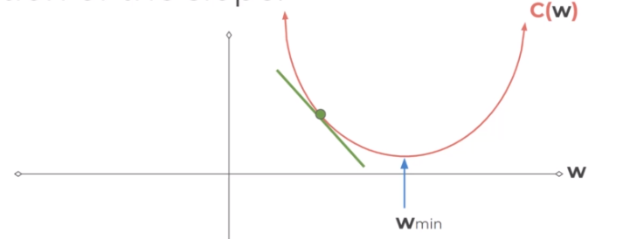

* + - Until we converge to zero, indicating a minimum

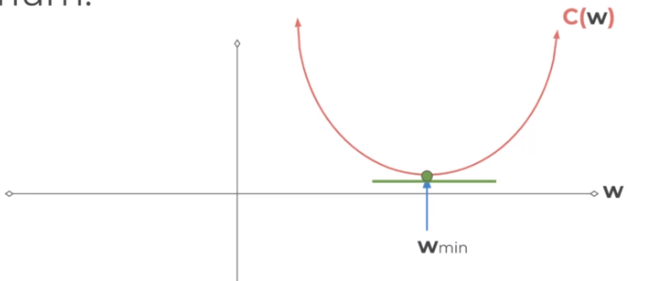

* + - We could have changed our step size to find the next point

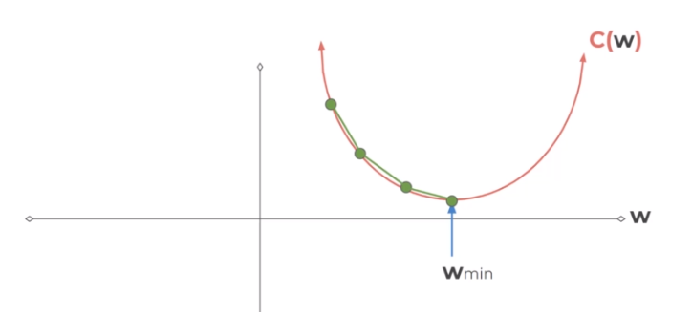

* + - Smaller step sizes take longer to find the minimum

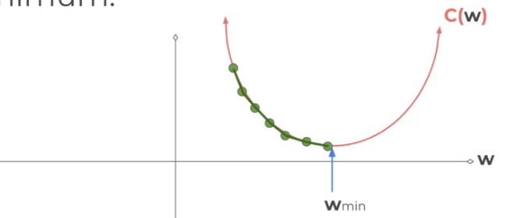

* + - Larger steps are faster, but we risk overshooting the minimum

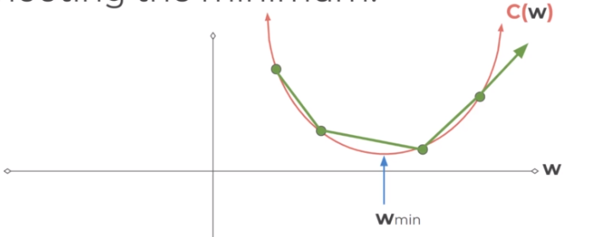

* + - The step size is known as the **learning rate**
  + The learning rate we showed in our illustrations was constants (each step size was equal), but we can be clever and adapt our steps size as we go along
    - We could start with larger steps, then go smaller as we realize the slope gets closer to zero
    - This is known as **adaptive gradient descent**
    - In 2015, Kingma and Ba published their paper ‘Adam: A method for Stochastic Optimization’
    - Adam is a much more efficient way of searching for these minimums, so you will see us use it for our code
    - Adam versus other gradient descent algorithms

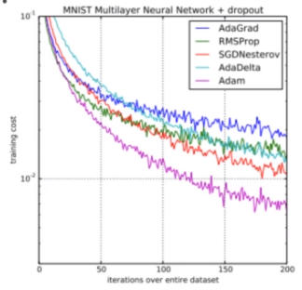

* + - Realistically we’re calculating this descent in an n-dimensional space for all our weights

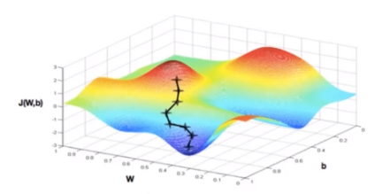

* + - When dealing with these N-dimensional vectors (tensors), the notation changes from **derivative** to **gradient**
    - This means we calculate **▽C(w1, w2, w3, …, wn)**
    - For classification problems, we often use the **cross entropy** loss function
    - The assumption is that your model predicts a probability distribution p(y=1) for each class i=1,2,…,C
    - For a binary classification this result in:

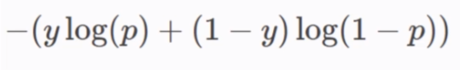

* + - For **M** number of classes >2

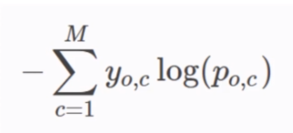

## Backpropagation

* We’ll start by building an intuition behind **backpropagation**, and then we’ll dive into the calculus and notation of backpropagation
* Fundamentally, we want to know how the cost function result changes with respect to the weights in the network, so we can update the weights to minimize the cost function
* Let’s begin with very simple network, where each layer only has 1 neuron
  + Each input will receive a weight and bias
  + This means we have: **C(w1, b1, w2, b2, w3, b3)**

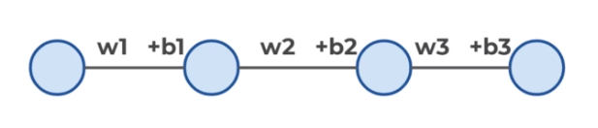

* + We’ve already seen how this process propagates forward
  + Let’s start the end to see the backpropagation
  + Let’s say we have **L** layers, then our notation becomes

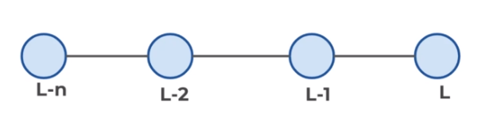

* + Focusing on these last two layers, let’s define **z = wx + b**
  + Then applying an activation function we’ll state **a = σ(z)**

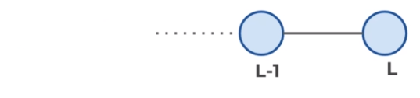

* + This means we have:
    - **zL = wLaL-1 + bL**
    - **aL = σ(zL)**
    - **C0 (...) = (aL – y)2**
  + We want to understand how sensitive is the cost function to changes in **w**
  + Using the relationships we already know along with the chain rule

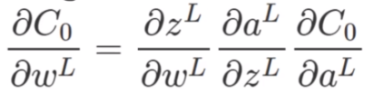

* + The main idea here is that we can use the gradient to go back through the network and adjust our weights and biases to minimize the output of the error vector on the last output layer
  + Using some calculus notation, we can expand this idea to networks with multiple neurons per layer
  + Hadamard Product

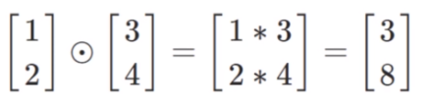

* + Given this notation and backpropagation, we have a few main steps to training neural networks
* Learning Process
  + Step 1
    - Using input **x** set the activation function **a** for the input layer
      * **z=w*x+b**
      * **a= σ(z)**
    - This resulting **a** then feeds into the next layer (and so on)
  + Step 2
    - For each layer, compute:
      * **zL = wLaL-1 + bL**
      * **aL = σ(zL)**
  + Step 3
    - We compute our error vector

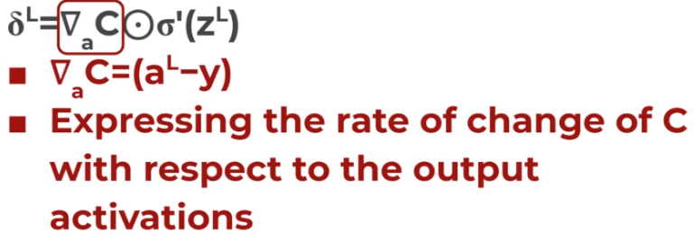

* + - Now let’s write out our error term for a layer in terms of the error of the next layer (since we’re moving backwards)
  + Step 4



* + - Backpropagate the error:
    - For each layer: L-1, L-2, … we compute:

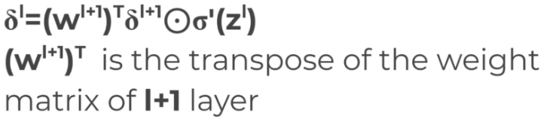

* + - When we apply the transpose weight matrix **(wl+1)T** we can think intuitively of this as moving the error backward through the network, giving us some sort of measure of the error at the output of the l-th layer
    - We then take the Hadamard product **Ꙩσl(zl)**. This moves the error backward through the activation function in layer **l**, giving us the error **δl** in the weighed input to layer **l**
    - The gradient of the cost function is given by
      * For each layer: L-1, L-2, … we compute

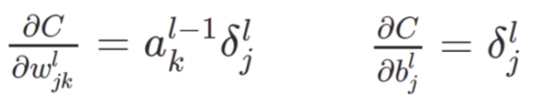

* + - * This then allows us o adjust the weights and biases to help minimize that cost function

## TensorFlow vs. Keras Explained

## Keras Syntax Basics - Part One - Preparing the Data

## Keras Syntax Basics - Part Two - Creating and Training the Model

# For a multi-class classification problem  
model.compile(optimizer='rmsprop',  
 loss='categorical_crossentropy',  
 metrics=['accuracy'])  
  
# For a binary classification problem  
model.compile(optimizer='rmsprop',  
 loss='binary_crossentropy',  
 metrics=['accuracy'])  
  
# For a mean squared error regression problem  
model.compile(optimizer='rmsprop',  
 loss='mse')  
'''

## Keras Syntax Basics - Part Three - Model Evaluation

## Keras Regression Code Along - Exploratory Data Analysis

## Keras Regression Code Along - Exploratory Data Analysis - Continued

## Keras Regression Code Along - Data Preprocessing and Creating a Model

Batch_size

* Typically – power of 2
* Smaller Batch_size – longer training, but less probability to overfit the data

## Keras Regression Code Along - Model Evaluation and Predictions

## Keras Classification Code Along - EDA and Preprocessing

## Keras Classification - Dealing with Overfitting and Evaluation

## TensorFlow 2.0 Keras Project Options Overview

## TensorFlow 2.0 Keras Project Notebook Overview

## Keras Project Solutions - Exploratory Data Analysis

## Keras Project Solutions - Dealing with Missing Data

## Keras Project Solutions - Dealing with Missing Data - Part Two

## Keras Project Solutions - Categorical Data

## Keras Project Solutions - Data PreProcessing

## Keras Project Solutions - Creating and Training a Model

## Keras Project Solutions - Model Evaluation

## Tensorboard

Tensorboard is a visualization tool from Google designed to work in conjunction with TensorFlow to visualize various aspects of your model.

### Creating the Tensorboard Callback

TensorBoard is a visualization tool provided with TensorFlow.

This callback logs events for TensorBoard, including:

* Metrics summary plots
* Training graph visualization
* Activation histograms
* Sampled profiling

If you have installed TensorFlow with pip, you should be able to launch TensorBoard from the command line:

sh

tensorboard --logdir=path_to_your_logs

You can find more information about TensorBoard <https://www.tensorflow.org/tensorboard/>

Arguments:

* **log_dir**: the path of the directory where to save the log files to be parsed by TensorBoard.
* **histogram_freq**: frequency (in epochs) at which to compute activation and weight histograms for the layers of the model. If set to 0, histograms won't be computed. Validation data (or split) must be specified for histogram visualizations.
* **write_graph**: whether to visualize the graph in TensorBoard. The log file can become quite large when write_graph is set to True.
* **write_images**: whether to write model weights to visualize as image in TensorBoard.
* **update_freq:** `'batch'` or `'epoch'` or integer. When using `'batch'`, writes the losses and metrics to TensorBoard after each batch. The same applies for `'epoch'`. If using an integer, let's say `1000`, the callback will write the metrics and losses to TensorBoard every 1000 samples. Note that writing too frequently to TensorBoard can slow down your training.
* **profile_batch:** Profile the batch to sample compute characteristics. By default, it will profile the second batch. Set profile_batch=0 to disable profiling. Must run in TensorFlow eager mode.
* **embeddings_freq**: frequency (in epochs) at which embedding layers will be visualized. If set to 0, embeddings won't be visualized.

# Convolutional Neural Networks - CNNs

## CNN Section Overview

CNNs are a specific architecture of Neural Networks that are extremely effective at dealing with image data.

CNN Section

* Understanding CNNs
  + Image Kernels and Filters
  + Convolutions
  + Pooling Layers
* MNIST Dataset (Grayscale Images)
* CIFAR-10 Dataset (Color Images)

## Image Filters and Kernels

* Cpmputer vision is a general term of using computer programs to process image data
* Photo editing software – filters – blur filter



* + Filters are essentially an image kernel, which is a small matrix applied to an entire image
  + Certain popular filters are well known, for example a blur filter

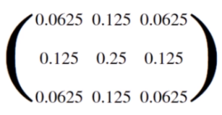

* + Applying a filter to the images – the resolution is decreasing

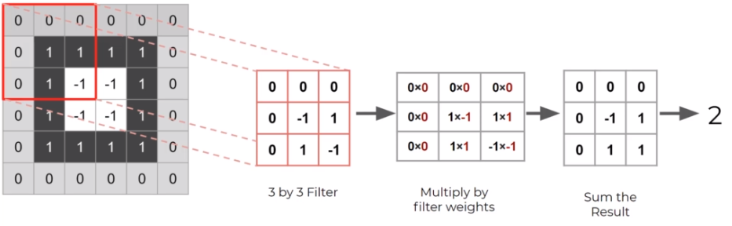

* + We can also edit our stride distance

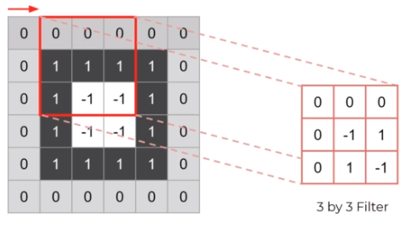

* + Stride Distance of 2 Example

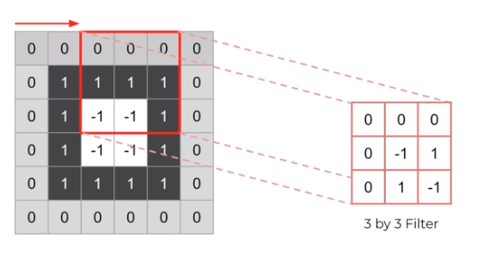

* + Interactive example - <https://setosa.io/ev/image-kernels/>
  + In the context of CNNs, these „filters” are referred to as **convolution kernels**
  + The process of passing tchem over an image is known as **convolution**
  + During convolution we would lose borders

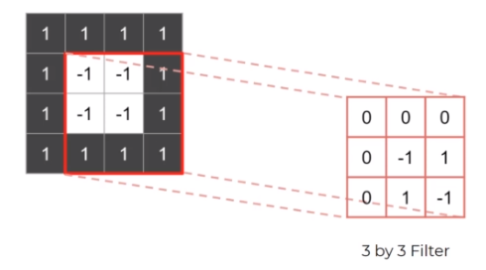

* + - We can **pad** the image with more values – this allows us to preserve the image size

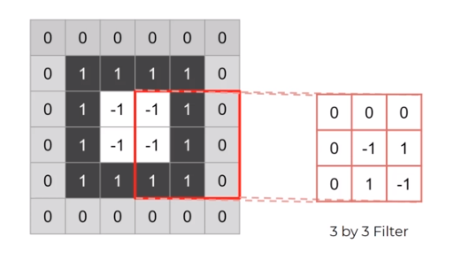

* + **Convolutional layer** allows the network to come up with the best weights for a filter

## Convolutional Layers

* Recall that running an ANN for the MNIST data set resulted in a network with relatively good accuracy.
* However, there are some issues with always using ANN models for image data.
* ANNs
  + Large amount of parameters (over 100,000 for tiny 28 by 28 images)
  + We lose all 2D information by flattening out the image
  + Will only work on very similar, well centered images.
* A CNN can use convolutional layers to help alleviate these issues.
* A convolutional layer is created when we apply multiple image filters to the input images.
* The layer will then be trained to figure out the best filter weight values.
* A CNN also helps reduce parameters by focusing on **local connectivity.**
* Not all neurons will be fully connected.
* Instead, neurons are only connected to a subset of local neurons in the next layer (these end up being the filters!)
* Let’s understand this local connectivity and its connection to filters by beginning with a simplified 1-D example.
* We will later expand this to 2-D inputs for a grayscale image and then later on to 3-D tensor inputs for color images.
* ANN
  + Fully connected, lots of parameters

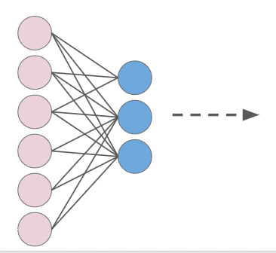

* CNN
  + Convolutional layer – localized connections
  + Here have 1 filter

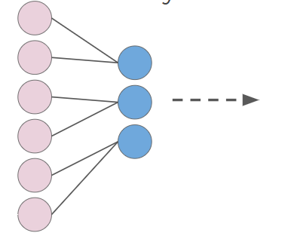

* + Here have 2 filters

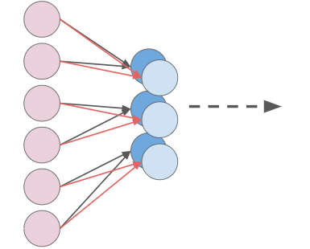

We just saw a 1-D example of convolution, but recall, grayscale images are 2-D! Plus we want to preserve that 2-D relational information in the convolutional layer.

* 3D

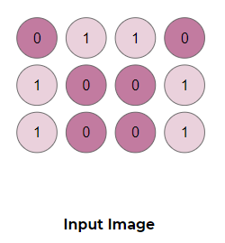

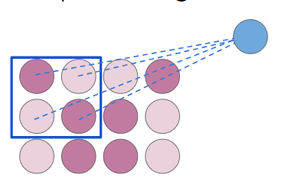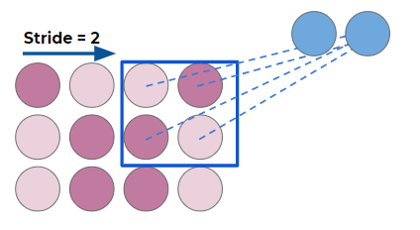

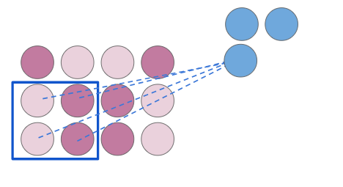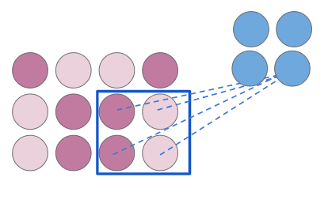

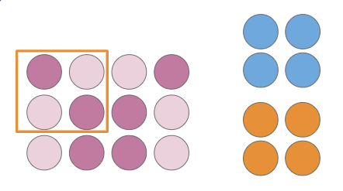

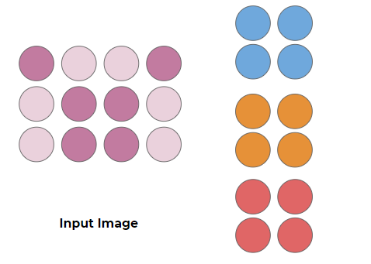

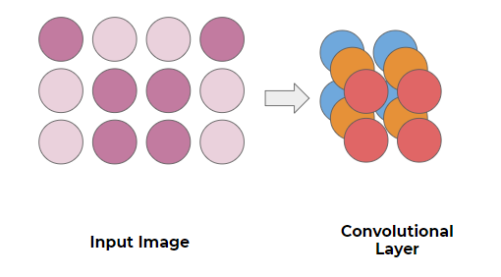

But this was just in 2D for grayscale images. What about color images? Color Images can be thought of as 3D Tensors consisting of Red, Green, and Blue color channels.

* Additive color mixing allows us to represent a wide variety of colors by simply combining different amounts or R, G, B.



* RGB allows to produce a range of colors

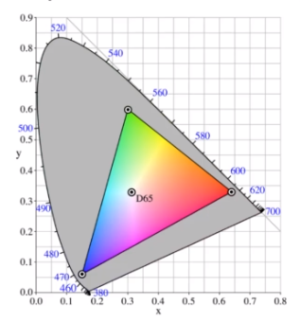

* Each color channel will have intensity values.
* You may have already seen this sort of representation in other software with RGB sliders.

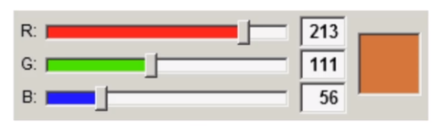

* Example
  + The shape of the color array then has 3 dimensions.
    - Height
    - Width
    - Color Channels

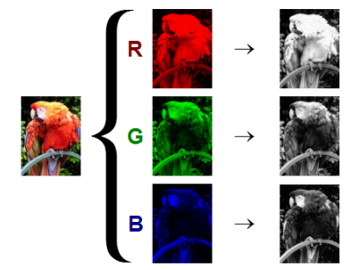

* + This means when you read in an image and check its shape, it will look something like: **(1280,720,3)**
    - **1280** pixel width
    - **720** pixel height
    - **3** color channels
  + This means when you read in an image and check its shape, it will look something like: **(720,1280,3)**
    - **720** pixel height
    - **1280** pixel width
    - **3** color channels

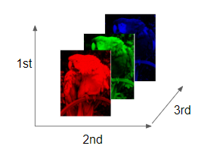

* + Keep in mind the computer won’t “know” a channel is Red, it just knows that there are now 3 intensity channels.
* Filters on 3D images
  + How do we then perform a convolution on a color image?
  + We end up with a 3D filter, with values for each color channel.

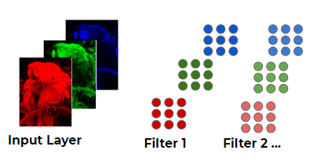

* + Often convolutional layers are fed into another convolutional layer.
  + This allows the networks to discover patterns within patterns, usually with more complexity for later convolutional layers.

We’ve learned a lot so far and we have one final theory topic to cover before coding our own CNNs, and that is the Pooling Layer! (also known as a downsampling layer)

## Pooling Layers

### Pooling

* Even with local connectivity, when dealing with color images and possibly 10s or 100s of filters we will have a large amount of parameters.
* We can use pooling layers to reduce this.
* Pooling layers accept convolutional layers as input:

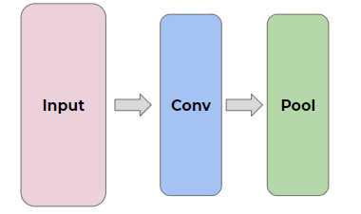

* Our convolutional layers will often have many filters

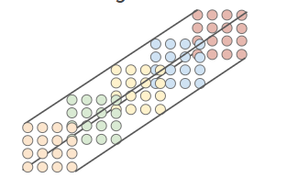

* Example
  + Let’s imagine a filter
  + We can reduce the size with subsampling

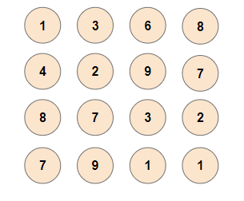

* + Max Pooling: Window 2x2, Stride: 2

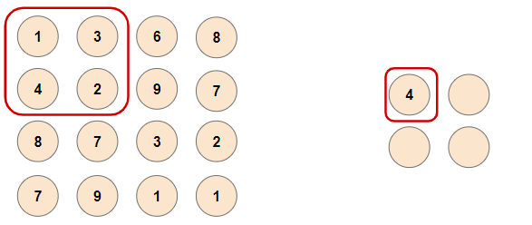 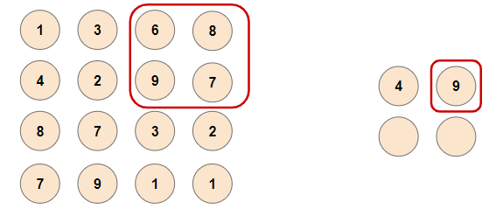

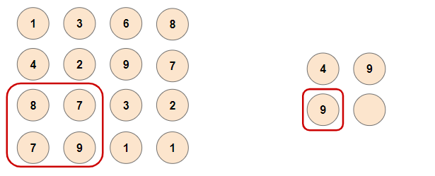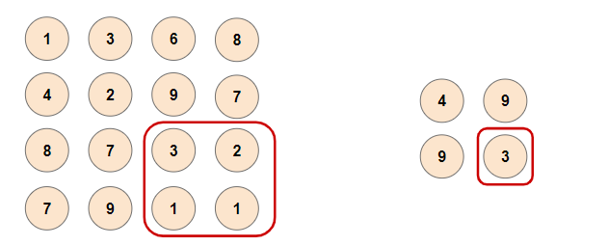

* + Avarage Pooling: Window 2x2, Stride: 2

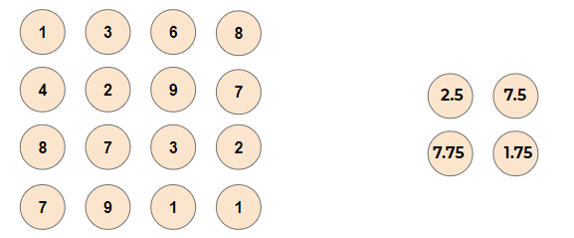

* This greatly reduces our number of parameters!

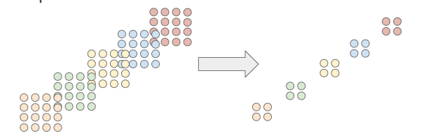

* This pooling layer will end up removing a lot of information, even a small pooling “kernel” of 2 by 2 with a stride of 2 will remove 75% of the input data.

### Dropout

* Another common technique deployed with CNN is called “Dropout”
* Dropout can be thought of as a form of regularization to help prevent overfitting.
* During training, units are randomly dropped, along with their connections.
* This helps prevent units from “co-adapting” too much.
* Let’s also quickly point out some famous CNN architectures!

### Famous CNN architectures

* LeNet-5 by Yann LeCun
* AlexNet by Alex Krizhevsky et al.
* GoogLeNet by Szegedy at Google Research
* ResNet by Kaiming He et al.
* Check out the resource links to the papers discussing these architectures!

AlexNet

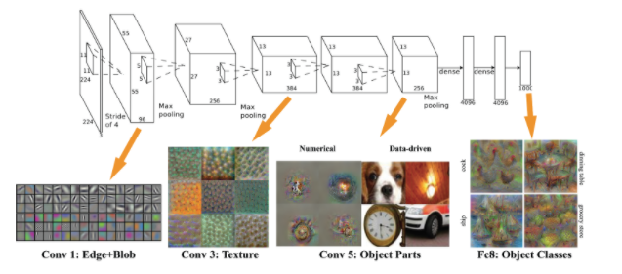

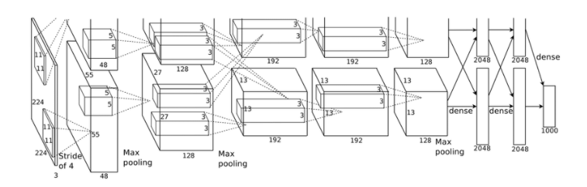

CNN can have all types of architectures

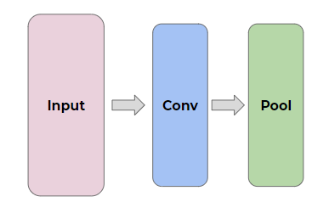

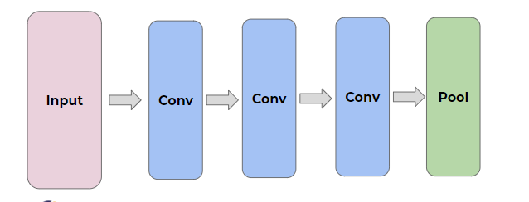

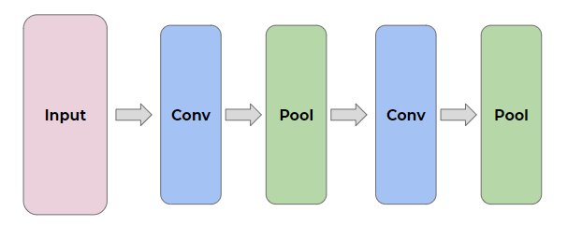

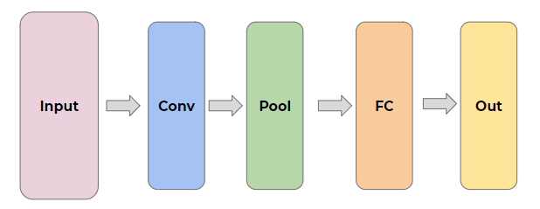

## MNIST Data Set Overview

* A classic data set in Deep Learning
* Fortunately this data is easy to access with PyTorch Vision. We will download:
  + 60,000 training images
  + 10,000 test images
* The MNIST data set contains handwritten single digits from 0 to 9

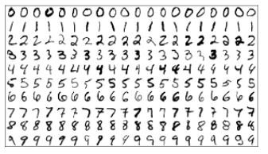

* A single digit image can be represented as an array

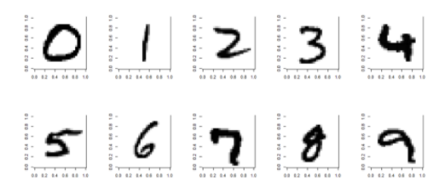

* Specifically, 28 by 28 pixels, the values represent the grayscale image

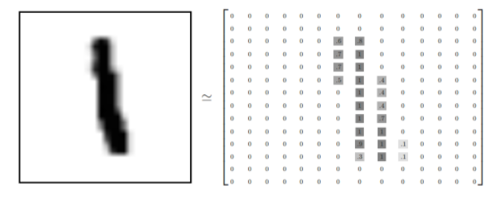

* We can think of the entire group of the 60 000 images as a 4-dimensional array. 60 000 of 1 channel 28 by 28 pixels
  + This array has 4 dimensions (60000, 28, 28, 1) – (samples, x, y, channels) (for color images, the last dimension value would be 3 (RGB))

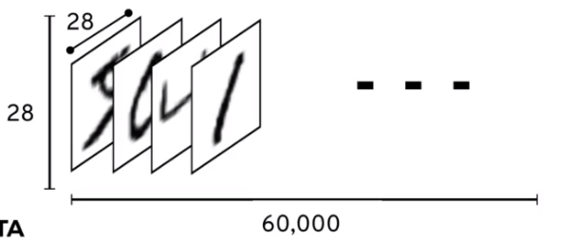

* + For the labels we’ll use One-Hot Encoding.
  + This means that instead of having labels such as “One”, “Two”, etc… we’ll have a single array for each image.
  + The label is represented  based off the index position in the label array.
  + The corresponding label will be a 1 at the index location and zero everywhere else.
  + For example, 4 would have this label array: [0,0,0,0,1,0,0,0,0,0]
  + As a result, the labels for the training data ends up being a large 2-d array (60000, 10)

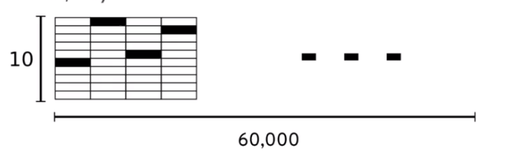

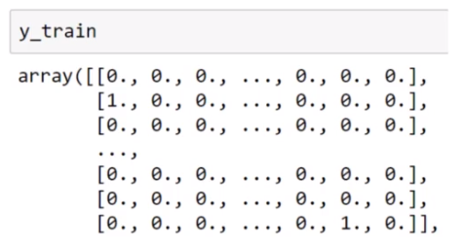

* We will first explore how we could approach this data set with a standard ANN.
* In this case, to feed it into our network we will need to flatten the 28 by 28 array to 784

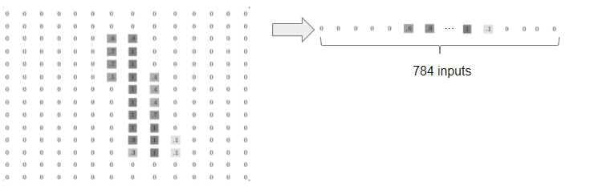

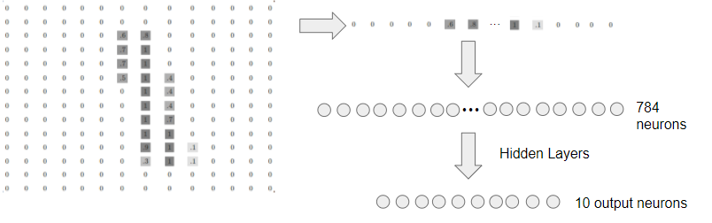

* Flattening out the image  ends up removing some of the 2-D information, such as the relationship of a pixel to its neighboring pixels.
* For now, we’ll ignore this, but come back to it later when we discuss CNN in depth!

## CNN on MNIST - Part One - The Data

## CNN on MNIST - Part Two - Creating and Training the Model

## CNN on MNIST - Part Three - Model Evaluation

Padding:

* VALID: Don't apply any padding, i.e., assume that all dimensions are **valid** so that input image fully gets covered by filter and stride you specified.
* SAME: Apply padding to input (if needed) so that input image gets fully covered by filter and stride you specified. For stride 1, this will ensure that output image size is **same** as input.

28x28 pixels image, kernel – (4, 4), so 28/4=0, we don’t need padding (?)

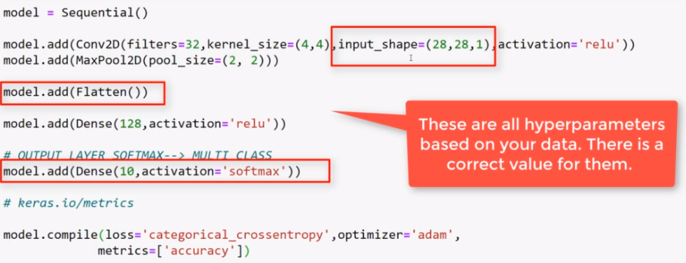

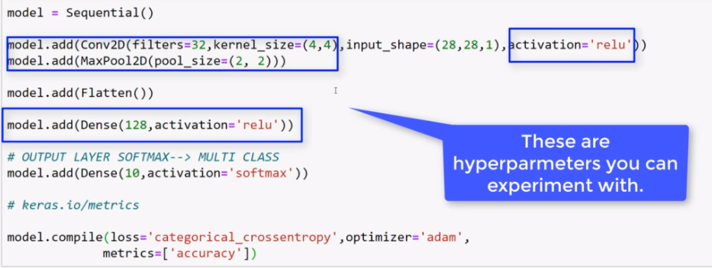

## CNN on CIFAR-10 - Part One - The Data

Cifar-10 dataset are 32by32 color images of 10 different objects:

* Airplane
* Car
* Bird
* Cat
* Deer
* Dog
* Frog
* Horse
* Ship
* truck

## CNN on CIFAR-10 - Part Two - Evaluating the Model

## Downloading Data Set for Real Image Lectures

## CNN on Real Image Files - Part One - Reading in the Data

## CNN on Real Image Files - Part Two - Data Processing

Image Data Generator

In order to use .flow_from_directory, you must organize the images in sub-directories. This is an absolute requirement, otherwise the method won't work. The directories should only contain images of one class, so one folder per class of images.

Structure Needed:

* Image Data Folder

* Class 1

* 0.jpg

* 1.jpg

* ...

* Class 2

* 0.jpg

* 1.jpg

* ...

* ...

* Class n

## CNN on Real Image Files - Part Three - Creating the Model

<https://stats.stackexchange.com/questions/148139/rules-for-selecting-convolutional-neural-network-hyperparameters>

Batch size – power of 2, larger hardware – larger batch size, smaller batch size – longer training because feeding less images at the time

## CNN on Real Image Files - Part Four - Evaluating the Model

## CNN Exercise Overview

## CNN Exercise Solutions

# Recurrent Neural Networks - RNNs

## RNN Section Overview

We’ve used Neural Networks to solve Classification and Regression problems, but we still haven’t seen how Neural Networks can deal with sequence information.

Just as CNNs were more effective for use with 2D image data, RNNs are more effective for sequence data (e.g. time-stamped sales data, sequence of text, heart beat data, etc…)

* Time Series

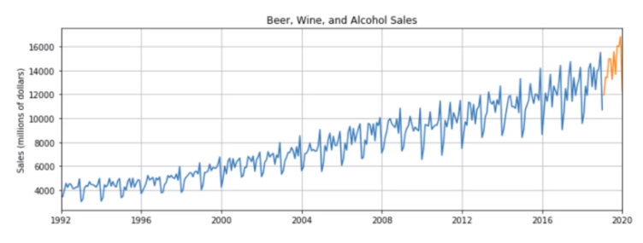

* Sequences

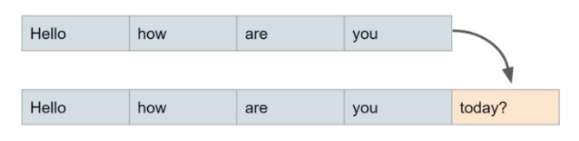

Section Overview

* RNN Theory
* LSTMs and GRU Theory
* Basic Implementation of RNN
* Time Series with an RNN
* Exercise and Solution

## RNN Basic Theory

* Examples of Sequences
  + Time Series Data (Sales)
  + Sentences
  + Audio
  + Car Trajectories
  + Music
* Let’s imagine a sequence: [1,2,3,4,5,6]
  + Would you be able to predict a similar sequence shifted one time step into the future? [2,3,4,5,6,7]
  + To do this properly, we need to somehow let the neuron “know” about its previous history of outputs.
  + One easy way to do this is to simply feed its output back into itself as an input!
  + To do this properly, we need to somehow let the neuron “know” about its previous history of outputs.
  + One easy way to do this is to simply feed its output back into itself as an input!

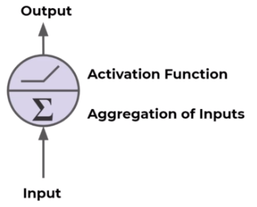

* + Recurrent Neuron
    - Sends output back to itself!
    - Let’s see what this looks like over time!

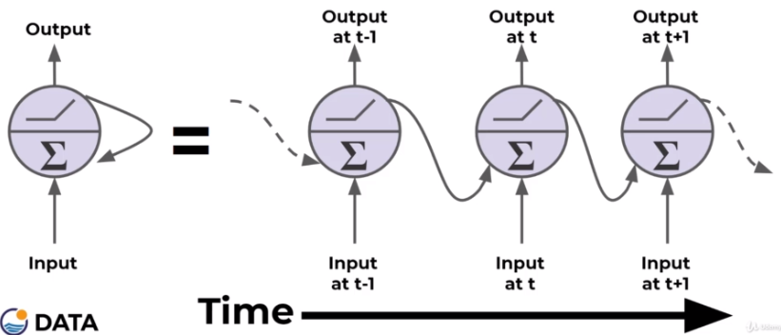

* + - Cells that are a function of inputs from previous time steps are also known as memory cells.
    - RNN are also flexible in their inputs and outputs, for both sequences and single vector values.
* We can also create entire layers of Recurrent Neurons...
  + ANN Layer with 3 Neurons:

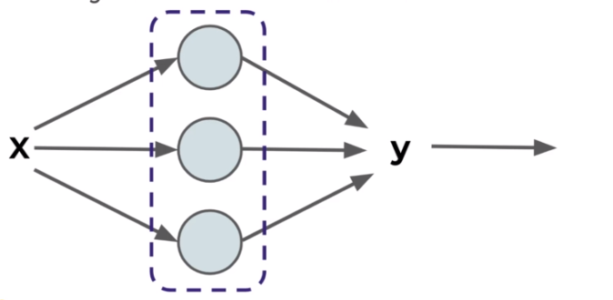

* + RNN Layer with 3 Neurons:

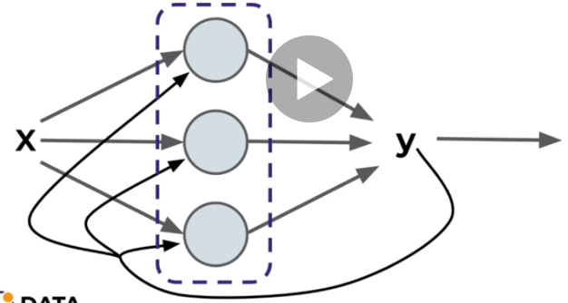

* + “Unrolled” layer.

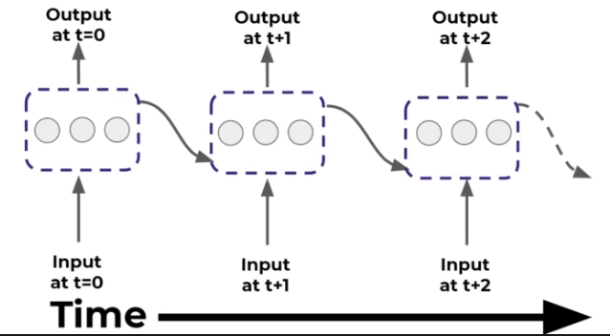

* + RNN are also very flexible in their inputs and outputs.
* Types of architectures
  + Sequence to Sequence (Many to Many)
    - Given 5 previous words, predict the next 5

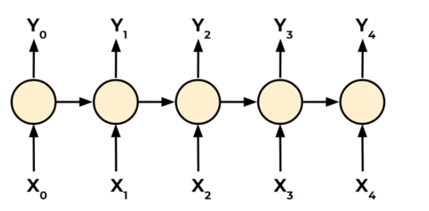

* + Sequence to Vector (Many to One)
    - Given 5 previous words, predict next word

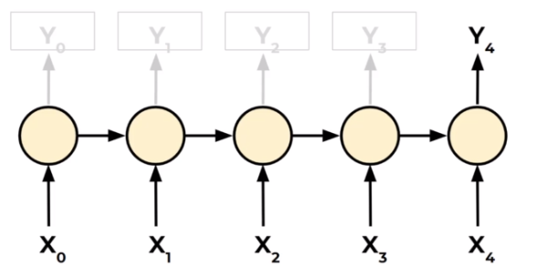

* + Vector to Sequence (One to Many)
    - Given 1 word predict the next 5 words

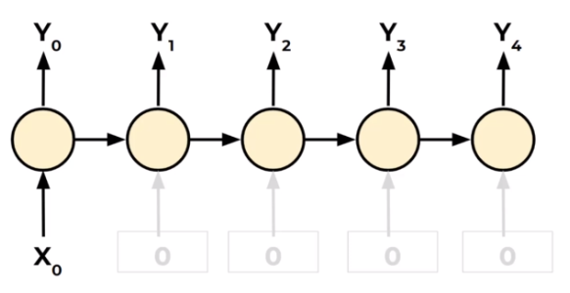

* A basic RNN has a major disadvantage, we only really “remember” the previous output.
* It would be great it we could keep track of longer history, not just short term history.
* Another issue that arises during training is the “vanishing gradient”.

## Vanishing Gradients

* As our networks grow deeper and more complex, we have 2 issues arise:
  + Exploding Gradients
  + Vanishing Gradients
* Recall that the gradient is used in our calculation to adjust weights and biases in our network.
* Let’s think about a network. – Feed Forward Network

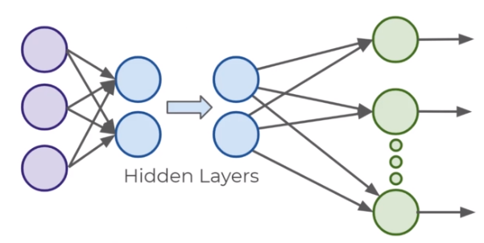

* For complex data we need deep networks

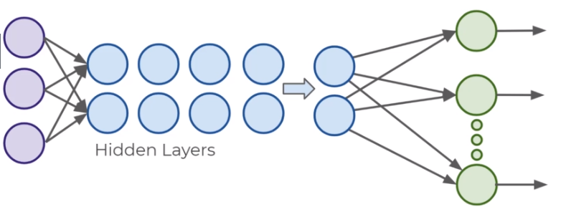

* Issue can arise during backpropagation

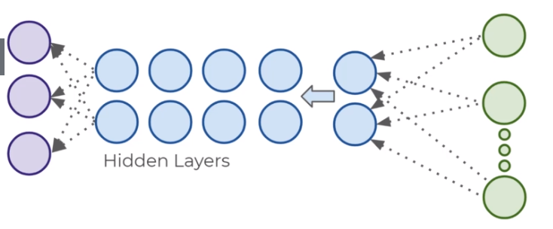

* Backpropagation goes backwards from the output to the input layer, propagating the error gradient.
* For deeper networks issues can arise from backpropagation, vanishing and exploding gradients!
* As you go back to the “lower” layers, gradients often get smaller, eventually causing weights to never change at lower levels.
* The opposite can also occur, gradients explode on the way back, causing issues.

Let’s discuss why this might occur and how we can fix it.

* Then in the next lecture we’ll discuss how these issues specifically affect RNN and how to use LSTM and GRU to fix them.
* Why does this happen?

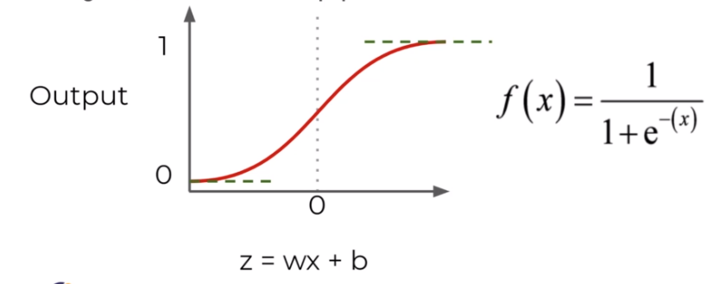

* + The derivative can be much smaller!

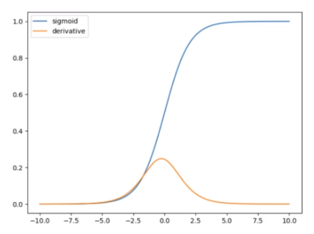

* + When n hidden layers use an activation like the sigmoid function, n small derivatives are multiplied together.
  + The gradient could decrease exponentially as we propagate down to the initial layers.
  + Using Different Activation Functions
    - The relu doesn’t saturate positive values

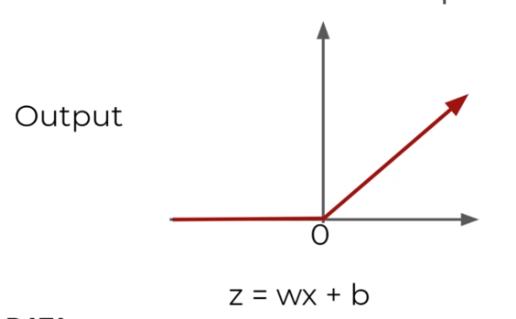

* + „Leaky” ReLU

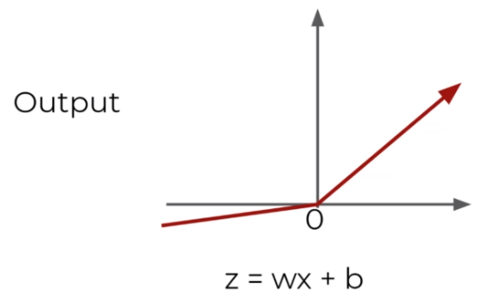

* + Exponential Linear Unit (ELU)

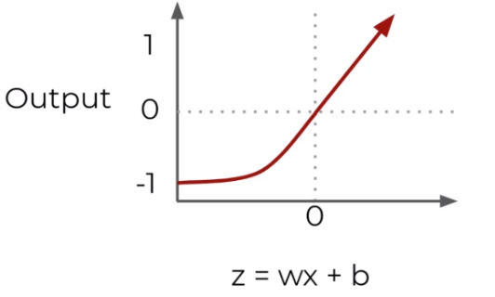

* + Another solution is to perform batch normalization, where your model will normalize each batch using the batch mean and standard deviation.
  + Choosing different initialization of weights can also help alleviate these issues (Xavier Initialization)..
  + Apart from batch normalization, researchers have also used “gradient clipping”, where gradients are cut off before reaching a predetermined limit (e.g. cut off gradients to be between -1 and 1)
  + RNN for Time Series present their own gradient challenges, let’s explore special LSTM (Long Short Term Memory) neuron units that help fix these issues!

## LSTMS and GRU

* Many of the solutions previously presented for vanishing gradients can also apply to RNN: different activation functions, batch normalizations, etc…
* However because of the length of time series input, these could slow down training
* A possible solution would be to just shorten the time steps used for prediction, but this makes the model worse at predicting longer trends.
* Another issue RNN face is that after awhile the network will begin to “forget” the first inputs, as information is lost at each step going through the RNN.
* We need some sort of “long-term memory” for our networks.
* The LSTM (Long Short-Term Memory) cell was created to help address these RNN issues.
* Let’s go through how an LSTM cell works!
* A typical RNN

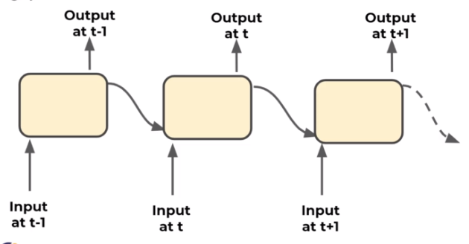

* + Single RNN

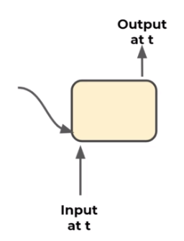 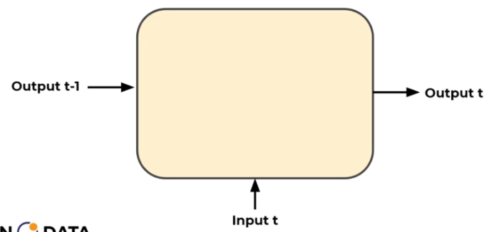 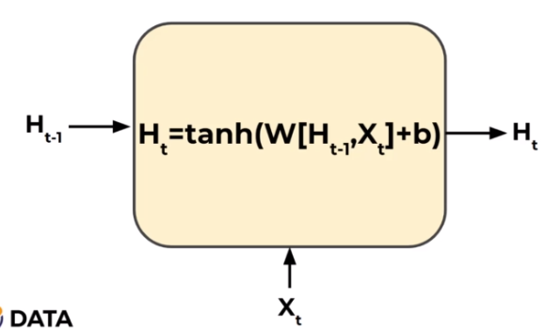

* + LSTM

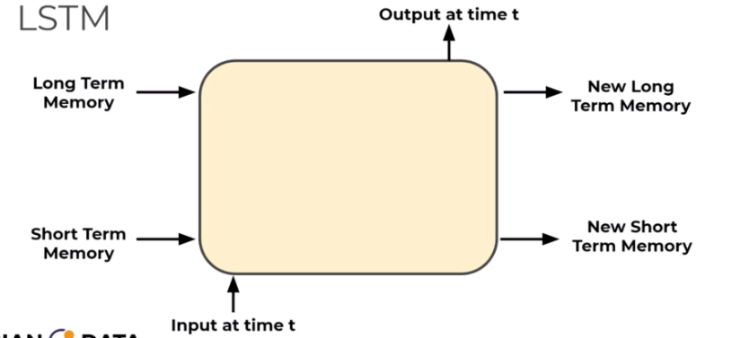 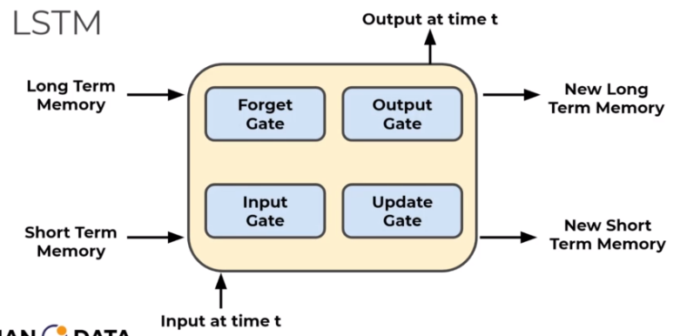

* + - Gates optionally let information through

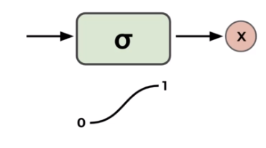

* + - Labels

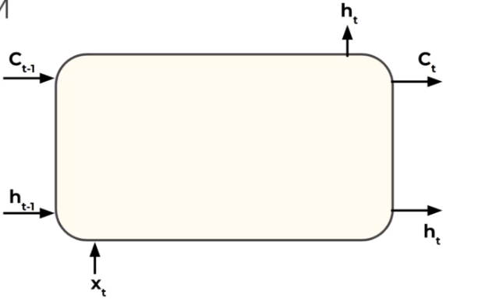

* + LSTM Cell

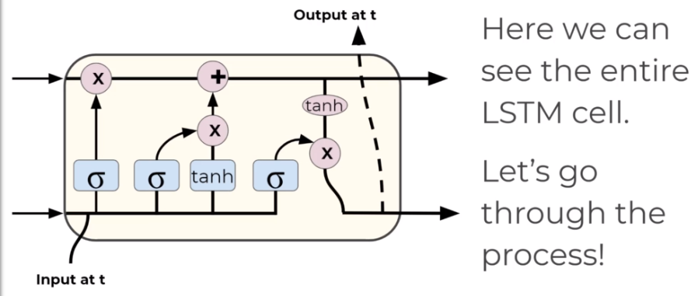

* + - First step – what we are going to forget? – Forget gate

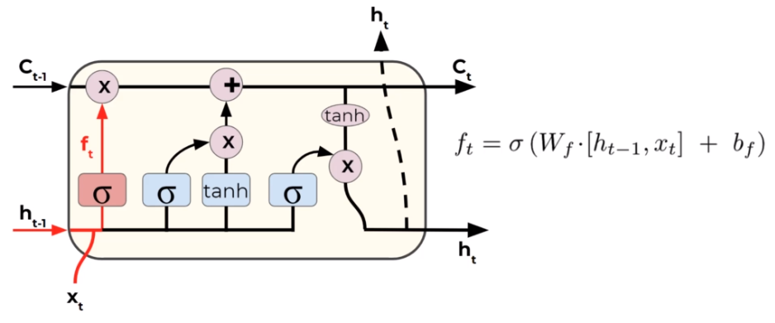

* + - Second step – what new information we are going to store in cell

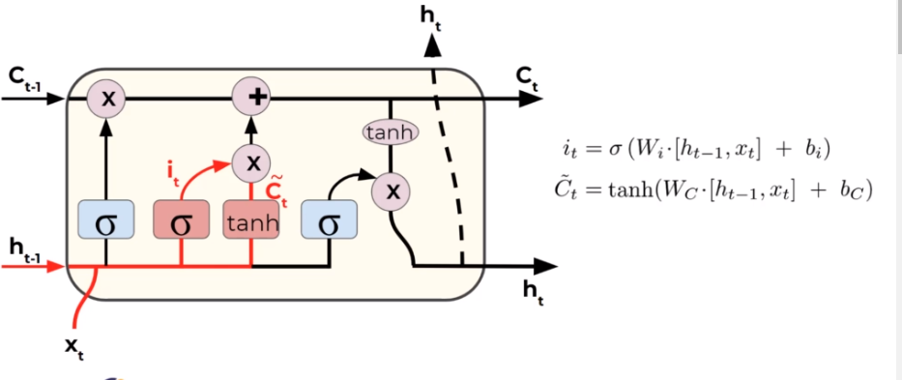

* + - Third step – update old cells

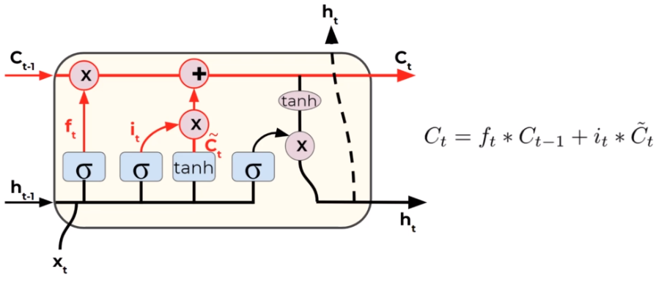

* + - Fourth step – what we are going to output – filtered version cel state

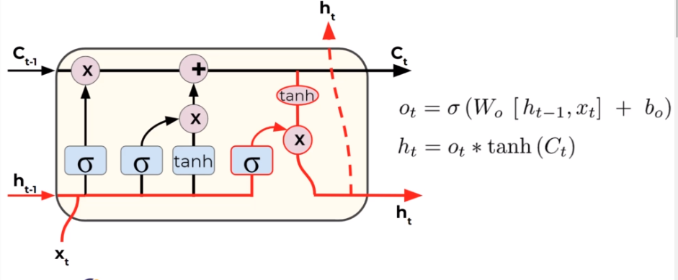

* + An LSTM Cell with “peepholes”

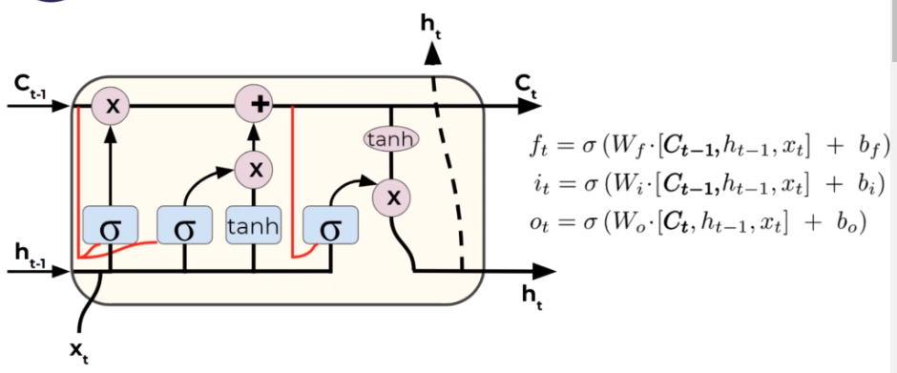

* + Gated Recurrent Unit (GRU)

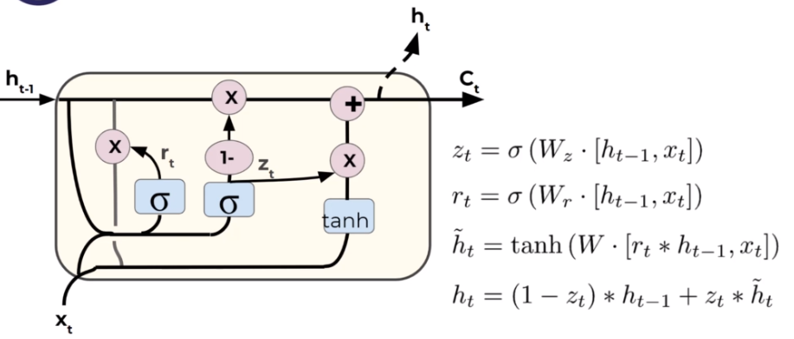

## RNN Batches

Let’s now explore how to use RNN on a basic time series, such as a sine wave.

* Let’s imagine a simple time series: [0,1,2,3,4,5,6,7,8,9]
  + We separate this into 2 parts:
    - [0,1,2,3,4,5,6,7,8] → [9]
  + Given training sequence, predict the next sequence value.
  + Keep in mind we can usually decide how long the training sequence and predicted label should be: [0,1,2,3,4] → [5,6,7,8,9]
  + We can also edit the size of the training point, as well as how many sequences to feed per batch:
    - [0,1,2,3] → [4]
    - [1,2,3,4] → [5]
    - [2,3,4,5] → [6]
  + So how do we decide how long the training sequence should be?
    - There is no definitive answer, but it should be at least long enough to capture any useful trend information.
* For example, if dealing with seasonal data

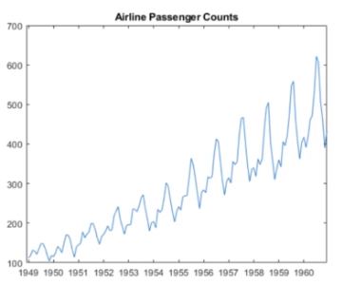

* + If this is monthly, we should include at least 12 months in the training sequence
  + This often takes domain knowledge and experience, as well as simply experimenting and using RMSE to measure error of forecasted predictions.
  + Typically a good starting choice for the label is just one data point into the future.

How do we forecast with RNNs?

* Let’s imagine all our data is: [0,1,2,3,4,5,6,7,8,9]
  + And we trained on sequences such as:
    - [0,1,2,3] → [4]
    - [1,2,3,4] → [5]
    - [2,3,4,5] → [6]
  + Then our forecasting technique is to predict a time step ahead, and then incorporate our prediction into the next sequence we predict off of.
  + Let’s walk through a quick example!
    - [6,7,8,9] → [10] Forecast prediction!
    - Then to keep predicting further:
    - [7,8,9,10] → [11.2]
    - [8,9,10,11.2] → [12.4]
    - [9,10,11.2,12.4] → [14]
    - [10,11.2,12.4,14] → Completed Forecast

## RNN on a Sine Wave - The Data

* Original data

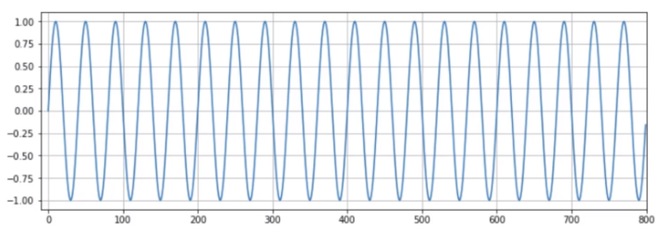

* We split this into train_set and test_set

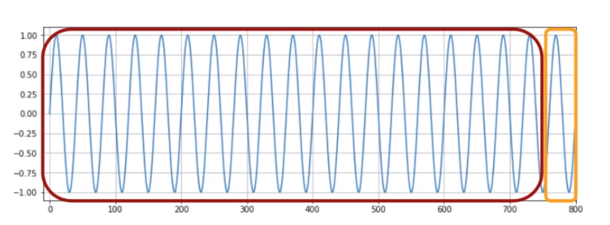

* During training, we could evaluate performance on the test data
* Let’s zoom the range – as we train, we will forecast on this range to visually see the training

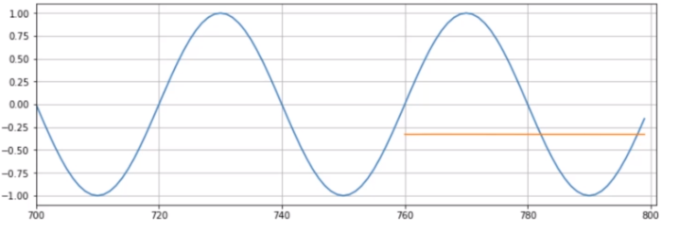

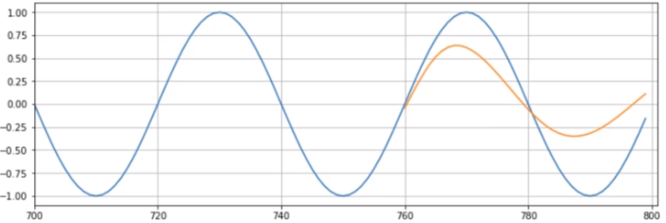

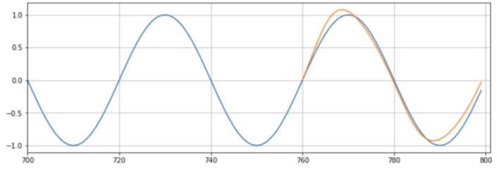

* Eventually once we are satisfied with the results on the test portion, it will be time to forecast into the unknown future.
* This means **retraining** on **all** available data (both train and test) and forecasting beyond the scope of the original data.
* Keep in mind, for real data, we would no longer have values to compare these predictions to!

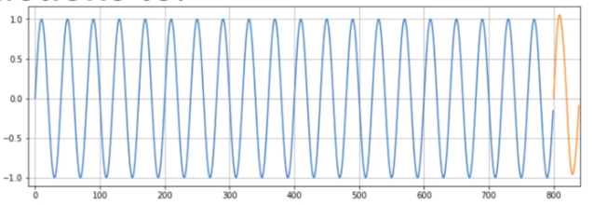

## RNN on a Sine Wave - Batch Generator

## RNN on a Sine Wave - Creating the Model

## RNN on a Sine Wave - LSTMs and Forecasting

## RNN on a Time Series - Part One

## RNN on a Time Series - Part Two

## RNN Exercise

## RNN Exercise – Solutions

## Bonus - Multivariate Time Series - RNN and LSTMs

* As a quick bonus, we’ll discuss how to use LSTMs and RNNs to predict multivariate time series.
* Keep in mind, there are a few cons to using LSTMs for this approach!
* As with all neural networks, the model is essentially a black box, difficult to interpret.
* Also there are many well-studied alternatives that are simpler, such as SARIMAX and VARMAX models.
* We highly recommend you try those more conventional approaches before settling on LSTMs or RNNs for multivariate time series data.
* Fortunately, setting up for multivariate data only requires 2 main changes.
* Multivariate Time Series:
  + Change input shape in LSTM layer to reflect 2-D structure
  + Final dense layer should have a neuron per feature/variable.
* Let’s explore these changes!

# Natural Language Processing

## Introduction to NLP Section

* Let’s explore how to work with text data in conjunction with deep learning!
* This is a natural extension of the time series and recurrent neural network topics we just discussed.
* We will create a neural network that will generate new text based on a corpus of text data.
* Check out “The Unreasonable Effectiveness of RNNs” by Andrej Karpathy
* So how will this work?
* Given an input string sequence, predict the sequence shifted forward 1 character.
  + **[“h” , ”e” , ”l” , ”l” ]**
  + **[“e” , ”l” , ”l” , ”o”]**
* The character based RNN will actually learn the structure of the text.
* In our example we will use the works of William Shakespeare.
* We will see the network clearly learn play writing structure and spacing, **just from a character level!**

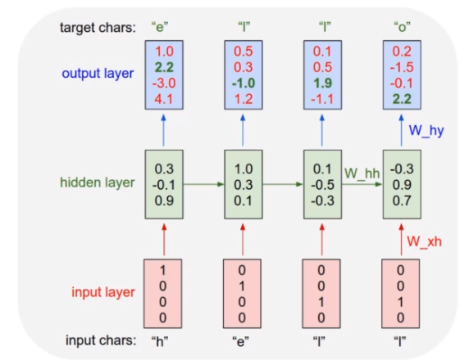

* Step 1: Read in Text Data
  + We can use basic built in python commands to read in a corpus of text as string data.
  + Note, you should have a large data set for this, at least 1 million characters for realistic results.
* Step 2: Text Processing and Vectorization
  + The neural network can’t take in raw strings, so we will encode them each to an integer.
    - A : 1
    - B : 2
    - C : 3
    - ? : 55
* Step 3: Creating Batches
  + We’ll use Tensorflow’s dataset object to easily create batches of text sequences.
    - [“h”, “e” , “l” , “l” , “o” , “ “, “m”]
    - [,“e” , “l” , “l” , “o” , “ “, “m”, “y”]
  + We’ll want to use sequence lengths that are long enough to capture structure and previous words.
  + But not so long that the sequence is just historical noise.
* Step 4: Creating the Model
  + We’ll use 3 layers
    - Embedding
    - GRU
    - Dense
  + Embedding Layer turns positive integers (indexes) into dense vectors of fixed size. eg. [[4], [20]] -> [[0.25, 0.1,0.3], [0.6, -0.2,0.9]]
  + Its up to the user to choose the number of embedding dimensions.
  + GRU
    - Gated Recurrent Unit is a special type of recurrent neuron unit.
    - The GRU is like a long short-term memory (LSTM) with forget gate but has fewer parameters than LSTM, as it lacks an output gate.

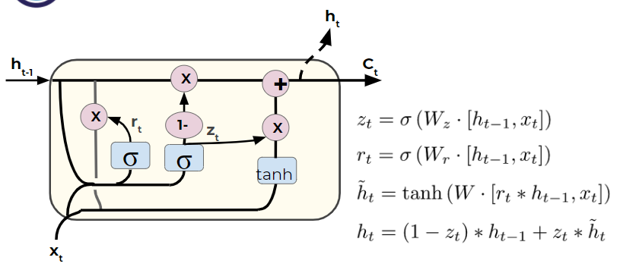

* + Dense Layer
    - One neuron per character.
    - Character labels will be one hot encoded so the final dense layer produces a probability per character.
    - Probability per character means we can play around with “temperature”:
      * Choosing less probable characters more/less often
* Step 5: Training the Model
  + We’ll set up our batches and make sure to one-hot encode our character labels.
* Step 6: Generating new text
  + We’ll save our models weights and show you how to reload a model’s weights with a different batch size in order to pass in single examples.

## NLP - Part One - The Data

## NLP - Part Two - Text Processing

## NLP - Part Three - Creating Batches

## NLP - Part Four - Creating the Model

## NLP - Part Five - Training the Model

## NLP - Part Six - Generating Text

# AutoEncoders

## Introduction to Autoencoders

* Welcome to the Autoencoders section of the course!
* Our use of autoencoders falls under unsupervised learning.
* Let’s quickly review what applications we will use autoencoders for and why this is unsupervised learning.
* We will use autoencoders for dimensionality reduction and noise removal.
* During the training of certain models, we will sometimes use historical data with correct labels, however during the actual use of the model, we won’t be able to use our previous evaluation metrics.
* Unsupervised learning means we won’t have “correct” labels to compare our results to.
* Our use cases for autoencoders in this section are sometimes called semi-supervised.
* Semi-supervised because we have the ability to use correct labels during the training of the autoencoder, but actually using the autoencoder we can’t produce metrics such as accuracy or RMSE.
* To fully understand this, we need to first understand how autoencoders work!
* Let’s explore the basics of autoencoders in the next lecture.

## Autoencoder Basics

* The autoencoder is actually a very simple neural network and will feel similar to a multi-layer perceptron model.
* It is designed to reproduce its input at the output layer.
* The key difference between an autoencoder and a typical MLP network is that the number of input neurons is equal to the number of output neurons.
* Let’s explore what this looks like and why we would use it!
* Example Autoencoder

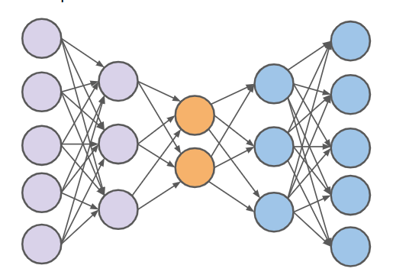

* Let’s walk through the layers and explain the basic idea of an autoencoder.

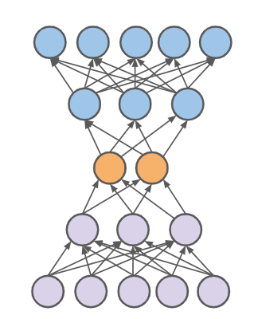

* + Let’s simplify this even further with just a single hidden layer.
  + In order to produce the same output at the final layer, the internal hidden layers must learn what features are important.
  + Here we see a design of 5 dimensions **reduced** to 2 dimensions, then expanded back to the original 5.

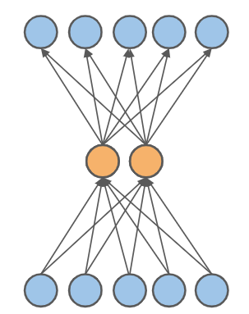

* + Feed forward network trained to reproduce its input at the output layer.
  + Output size is the same as the input layer.
  + The hidden representation attempts to maintain the important input information.
  + We can then use the hidden layer to extract meaningful insights.
  + This idea is extremely similar to PCA - Principal Component Analysis!
  + We can then explore stacked autoencoders with more hidden layers.

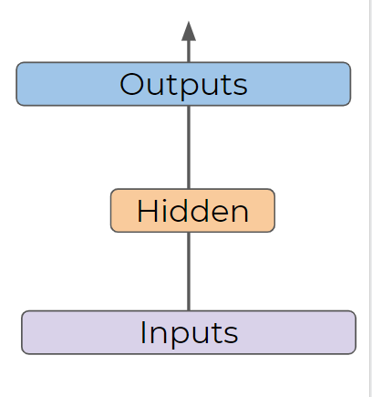

* **Important Note!**
  + The hidden layer is **NOT** simply sub-selecting only certain features.
  + Its calculating combinations of the original features represent the original data in a reduced dimensional space.
* Dimensionality Reduction

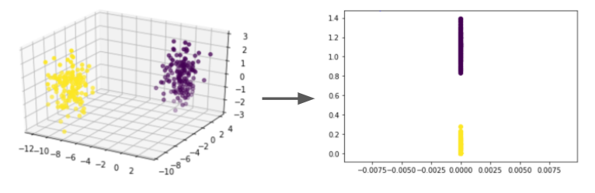

* The main idea behind an autoencoder:
  + The center hidden layer reduced the dimensionality to learn the most important combinations of original features.
* We’ll explore 2 use cases:
  + Dimensionality Reduction
  + Noise Removal

## Autoencoder for Dimensionality Reduction

* We can use an autoencoder for dimensionality reduction by separating it out into 2 parts:
  + Encoder
  + Decoder
* Example Autoencoder

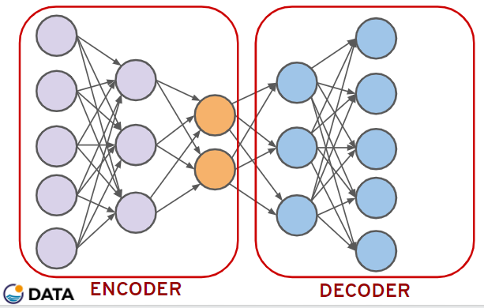

* This encoder can now successfully reduce dimensionality of the original data by taking combinations of the original features.
* What use cases does this have?
* Dimensionality Reduction
  + Compress data
  + Visualize data in lower dimensions
  + Reveal hidden relationships not clearly seen in higher dimensions

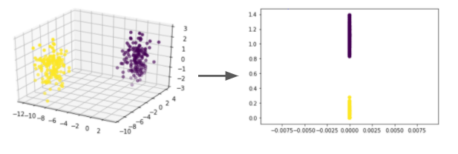

## Autoencoder for Images - Part One

* We’ve already seen that even simple images are high dimensional data sets.
* Recall a simple 28x28 image has 784 features/dimensions.

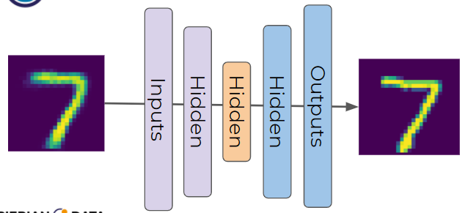

* We now have an autoencoder that understands what features of the 784 are important and which are not.
* For example, it likely understands that pixels on the edge don’t matter.
* We can use this same logic to create an autoencoder that removes noise, since the autoencoder knows what features are important.

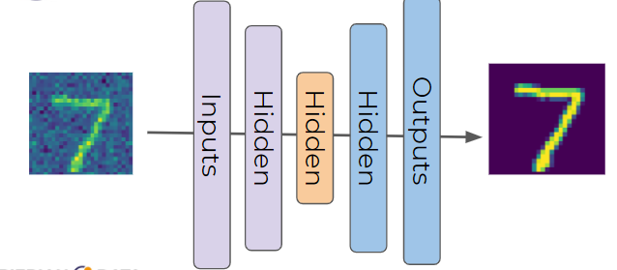

* Let’s explore 2 autoencoders
  + Attempt to recreate input images in the output.
  + Remove noise from input images to accurately reproduce output.

## Autoencoder for Images - Part Two - Noise Removal

## Autoencoder Exercise Overview

## Autoencoder Exercise – Solutions

# Generative Adversarial Networks

## GANs Overview

* GANs - Generative Adversarial Networks were invented in 2014 by Ian Goodfellow et al. and uses two networks competing against each other to generate data.
* GANs are often described as a counterfeiter versus a detective, let’s see how they work.
* Generator
  + Recieves random noise ( Gaussian distribution)
  + Outputs data (often an image)
* Discriminator
  + Takes a data set consisting of real images from the real data set and fake images from the generator.
  + Attempt to classify real vs fake images (always binary classification)
* The generator goal is to create images that fool the discriminator

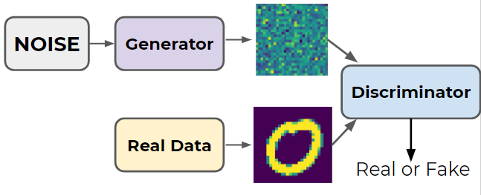

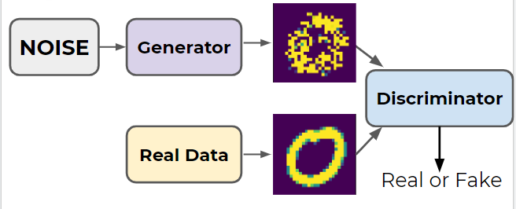

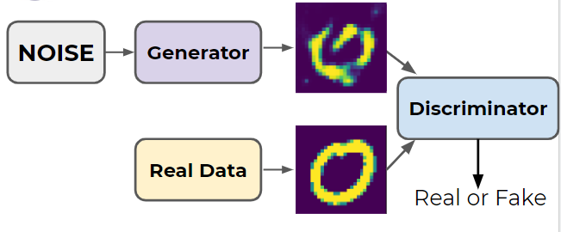

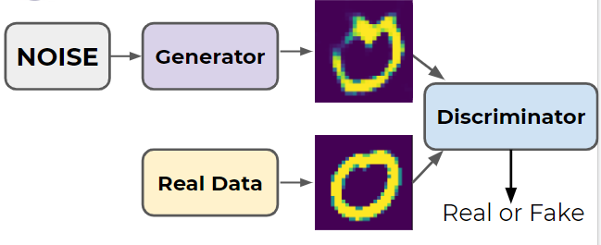

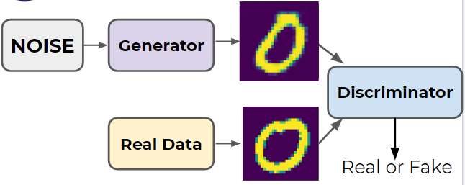

* Training Phases
  + Phase 1 - Train Discriminator
  + Phase 2 - Train Generator
* Phase 1: Discriminator
  + Real images (labeled 1) are combined with fake images from generator (labeled 0).
  + Discriminator trains to distinguish real from fake (with backpropagation only on discriminator weights)
* Phase 2: Generator
  + Produce fake images with generator.
  + Feed only these fake images to the generator with all labels set as real (1).
  + This causes the generator to attempt to produce images the discriminator believes to be real.
  + Because we feed in fake images all with labeled 1, we **only** perform backpropagation on the generator weights in this step.
* Keep in mind, the generator **never** gets to see the actual real images!
* It generates convincing images only based off gradients flowing back through the discriminator.
* Also keep in mind, the discriminator is also improving as training phases continuing, meaning the generated images will also need to get better and better.
* Face GAN Performance from NVIDIA

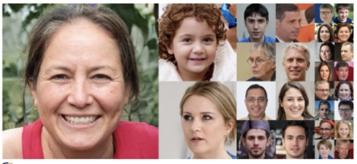

* Difficulties with GANs
  + Training Resources
  + Mode Collapse
  + Instability
* Training Resources
  + Since GANs are most often used for image based data, they require GPUs for reasonable training time.
  + Fortunately, Google Colab has GPUs available for free!
* Mode Collapse
  + Often the generator will figure out a few images (or a single image) that can fool the discriminator, and eventually “collapses” to only produce that image.
  + In theory it would be preferable to have a variety of images, such as multiple numbers or multiple faces, but GANs can quickly collapse to only produce a single number or face, regardless of input noise.
  + DCGANs (Deep Convolutional GANs) are better for avoiding mode collapse.
  + Researchers have also experimented with “mini-batch discrimination”, essentially punishing generated batches of images that are all too similar.
* Instability
  + It can be difficult to ascertain performance and appropriate training epochs since the generated images are always truly “fake”.
  + Due to the design of a GAN, the generator and discriminator are constantly at odds, leading to oscillation between performance between the two.
  + Experimenting with hyperparameters such as layers, neurons, activation functions, learning rates, etc… is usually required for complex images.
* Final Thoughts
  + GANs are a very popular area of research!
  + Make sure to do a quick search on Google Scholar for the latest research papers on this topic!

## Creating a GAN - Part One- The Data

## Creating a GAN - Part Two - The Model

## Creating a GAN - Part Three - Model Training

## DCGAN - Deep Convolutional Generative Adversarial Networks